11. Automata and languages, cellular automata, grammars, L-systems

11.1 Automata and languages

Automaton (pl. automata): in computer science, a simple model of a machine or of other systems. (→ a simplification of real machines or systems)

Examples:
Some systems to be modelled as automata with finite description

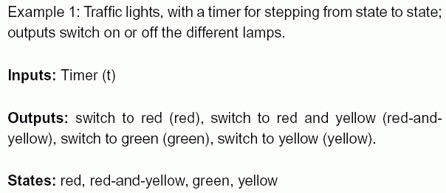

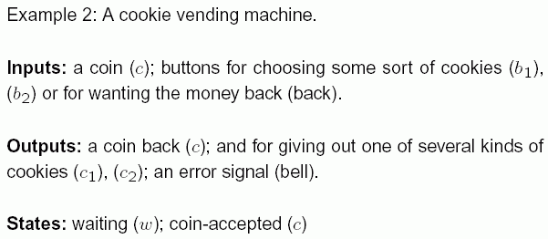
Example 3: A sugar-digesting bacterium

Inputs: glucose (g), lactose (l), nothing (n)

Outputs: lactase gene activated (a), lactase gene inactive (i) – can be measured in the laboratory by methods from molecular genetics

States: lactose-digesting (1), glucose-digesting (2), dormant (3)

Abstract notion: the Mealy automaton

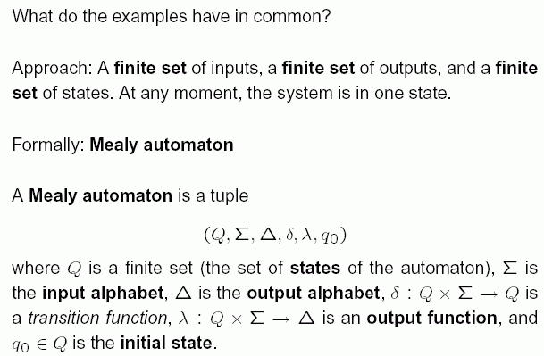

(remember: δ : Q × Σ → Q means that the function δ associates to each pair (q, s) with q from Q, s from Σ
an element δ(q, s) ∈ Q. For λ analogously.)

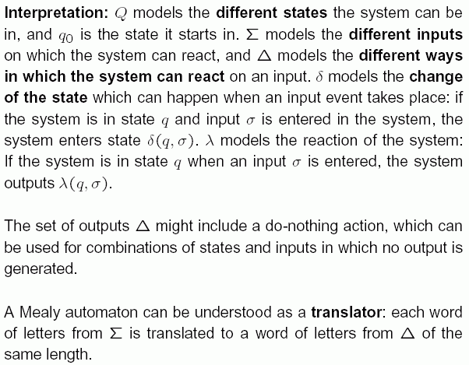

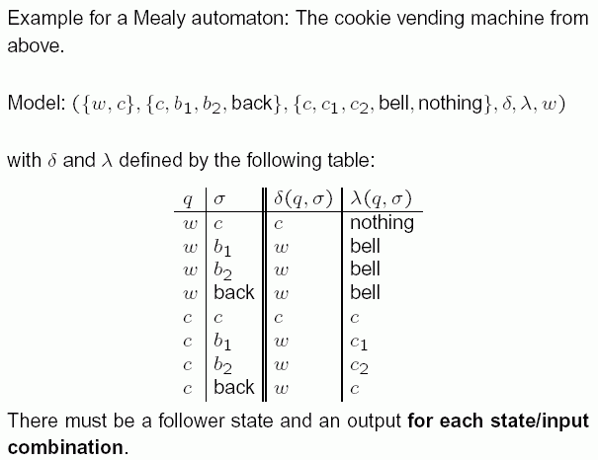
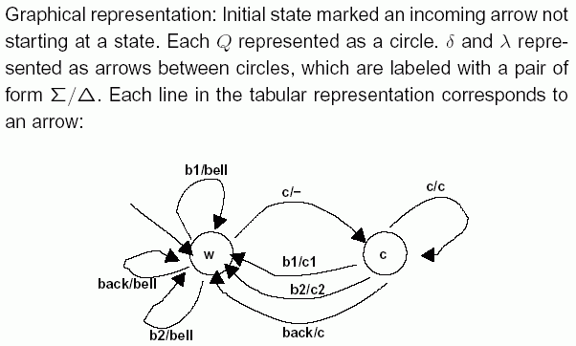

Formal languages:

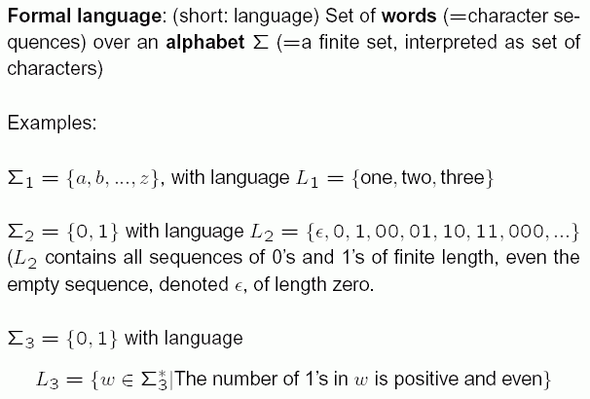
Definitions concerning words and formal languages:

The length |w| of a word w is the number of its letters.
The length of the empty word ε is 0.

The language of all finite words over an alphabet Σ, including the empty word, is denoted by Σ*.
(In the example above: L₂ = Σ₂* .)

The language of all non-empty words over Σ is denoted by Σ⁺. Σ⁺ = Σ* – {ε}.

The language of all words of length n over Σ is denoted by Σ^{n}. Σ⁰ = {ε}.

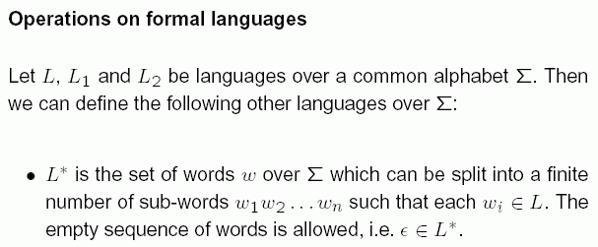

- L⁺ is defined similar to L*, only the empty sequence of subwords is not allowed. ε is in L⁺ only if it is already in L.

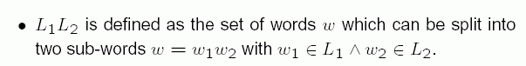

The connection between automata and formal languages:

How can we define a language using an automaton?

First idea: collect all input sequences for which the corresponding output of the automaton ends with a special symbol "accept".

→ Formal language definition by Mealy automata:

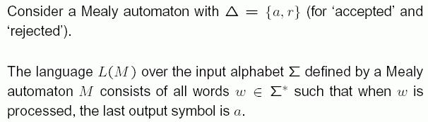

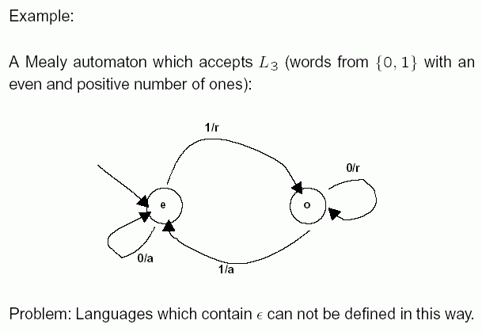
We simplify the notion of automaton:
The output is no longer necessary, only the states are used.

→ notion of "finite automaton" (FA); also called "deterministic finite automaton" (DFA):

A finite automaton is a quintuple
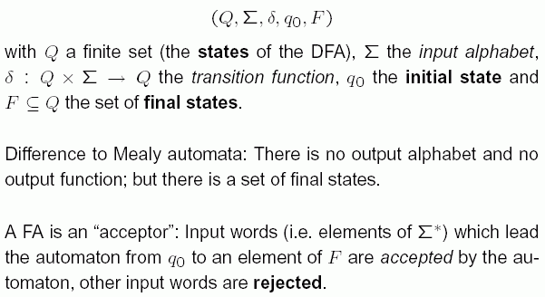

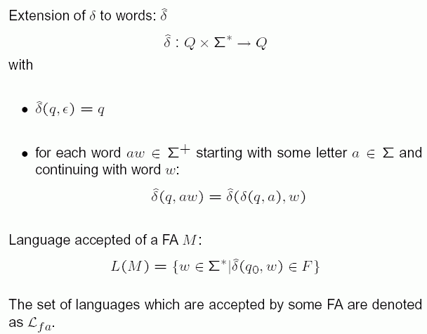
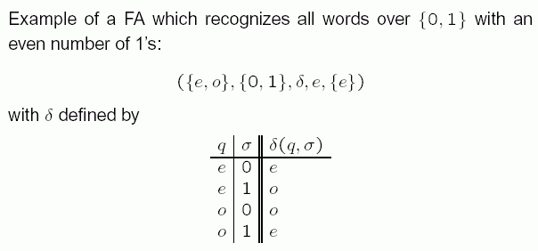

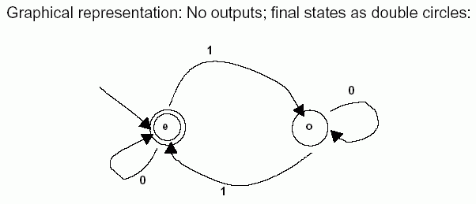

FA can be used to check the correctness of statements in simple programming languages ("accept" = input was syntactically correct; "reject" = an error was detected).
However, more complicated languages need other, more refined forms of automata.

The languages for which a finite automaton exists
form a special class of languages:

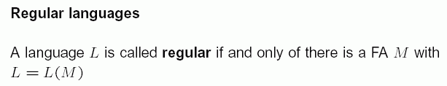
Regular expressions over an alphabet Σ

= a way to define "allowed" character sequences (or sequences of commands...), also used e.g. in search queries in databases or information systems
– stand in connection with regular languages

We give a recursive definition:

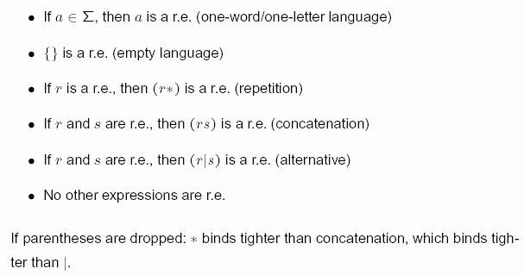

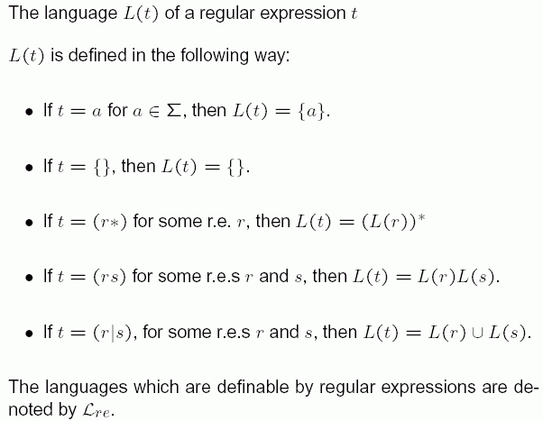

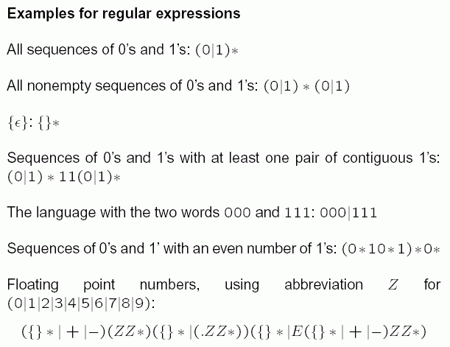
The connection to regular languages (i.e., to finite automata):

Theorem:
The languages which can be defined by regular expressions are exactly the regular languages.

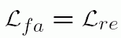

This justifies the word "regular" for languages definable by FA.

Proof: by construction of FAs for each of the alternatives for the construction of regular expressions, and vice versa.

Summary of this section:

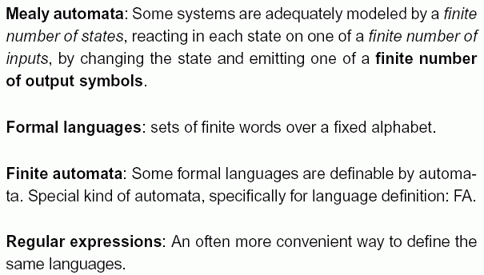

11.2 Cellular Automata

What will happen if we connect several finite automata with each other?

- A 2-dimensional Cellular Automaton (CA) is a rectangular (potentially infinite) array of cells. In each of the cells there is a finite automaton (→ each cell can adopt a finite number of states).
- All the automata in the cells have the same functioning.
- In each time step, each cell takes as input the states of all its neighbour cells and uses them to calculate its own new state (using a "transition function").

- The output of the CA is in each time step the pattern of the states of all the cells.

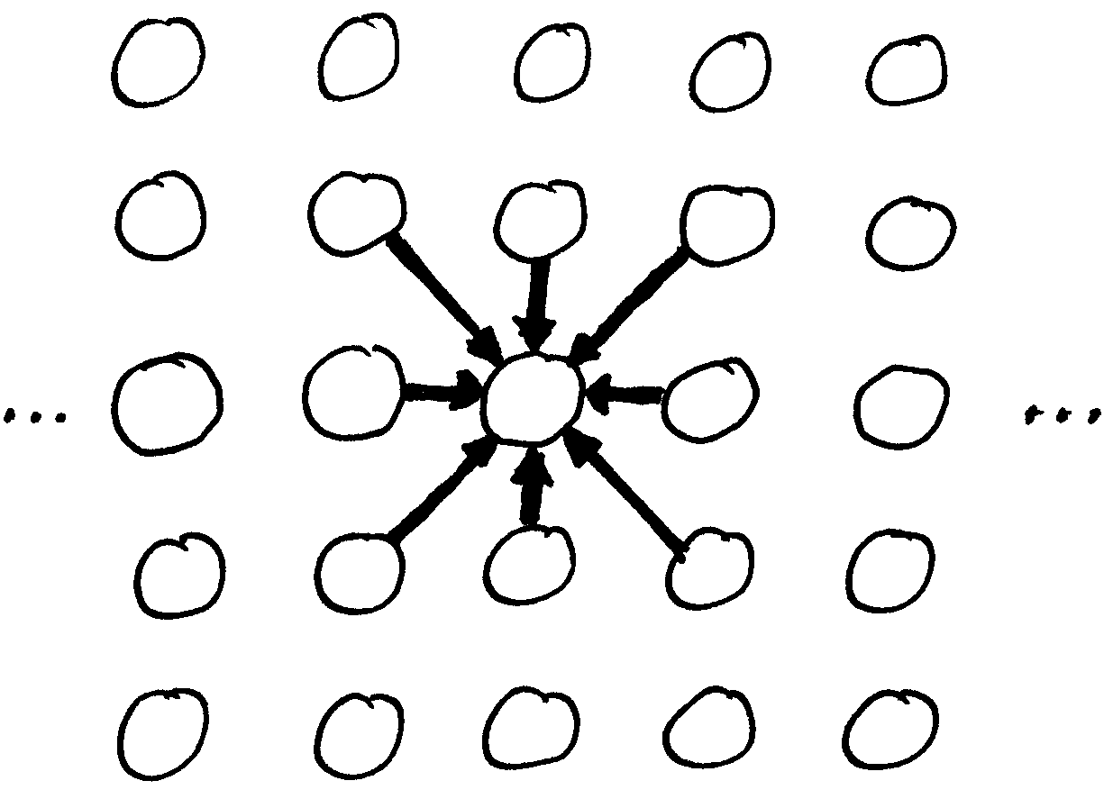

Formally: (G, Q, δ, c)
G_{(i,j)} : grid of cells with indices i, j
Q : set of states
δ : Q^{n+1} → Q transition function (works in each cell)
(n = size of the neighbourhood)
c : G → Q initial configuration

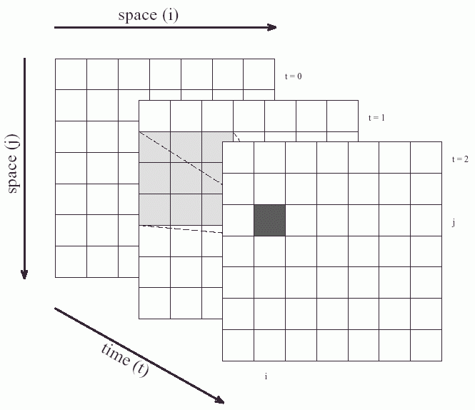

1- dimensional, 3-dimensional ... CA can be defined analogously. Sometimes also triangular or hexagonal
grids are used.

An example of a 2-dimensional CA:
Conway's "Game of Life"

Only 2 states: 1 = "living", 0 = "dead".
Neighbourhood: 8 cells (as above).
Simple transition rule, counting only the number of living cells in the neighbourhood as input.

Living cell, surrounded by 2 or 3 living cells → living
Dead cell, surrounded by exactly 3 living cells → living
in all other cases → dead
Expressed in other words:
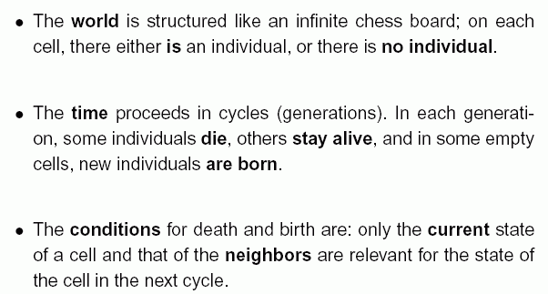

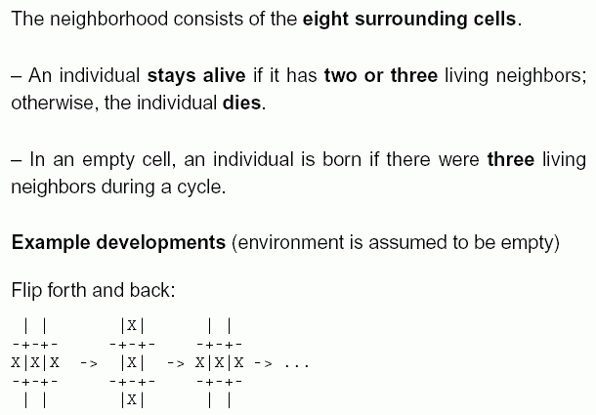

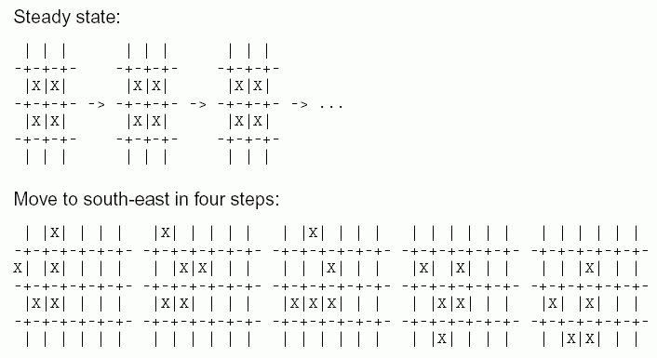
this configuration is called a "glider".

What else can happen in this simple "world"?

Other example development:
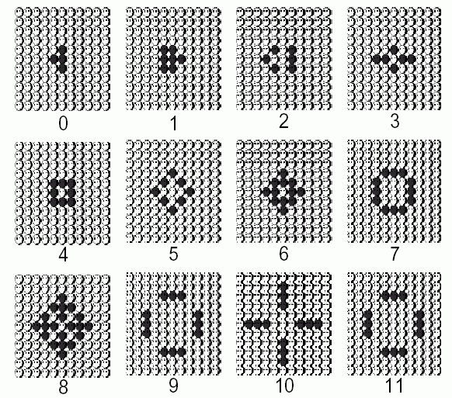
→ ends in a periodic pattern.

"Glider gun" (dark) emitting "gliders" (brighter):

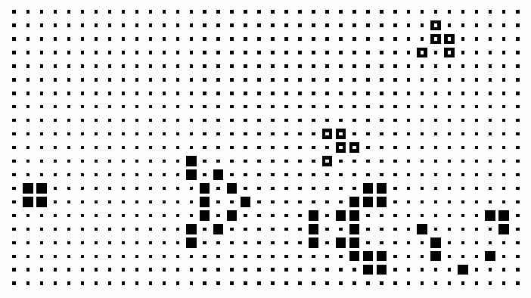

Computer scientists have shown that the Game of Life can even simulate a computer with logical circuits (AND, OR, NOT - switches) – hence all what can be calculated can be calculated using the Game of Life!

But: Game of Life rules do not reflect real-world properties
→ no significance for real-world ecological modelling

Using more states and other sets of transition rules,
cellular automata can be designed to simulate real-world spatial patterns and dynamics.

Examples:
- spreading of forest fires
- spreading of rabies disease in fox populations
- colonisation of a habitat by a new species
- formation of colour patterns on seashells
- chemical reaction patterns
- architecture...
Example: CA simulating the spreading of an epidemic (University of Leipzig)

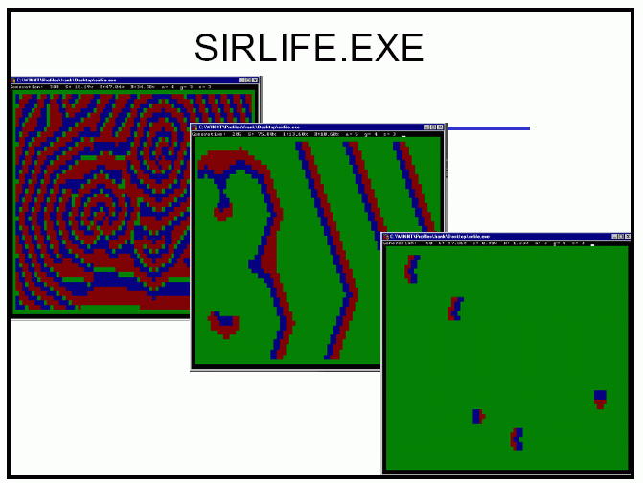

Example: Architectural interpretation of a 3-dimensional CA (Robert J. Krawczyk, http://www.iit.edu/~krawczyk/rjkga03.pdf)

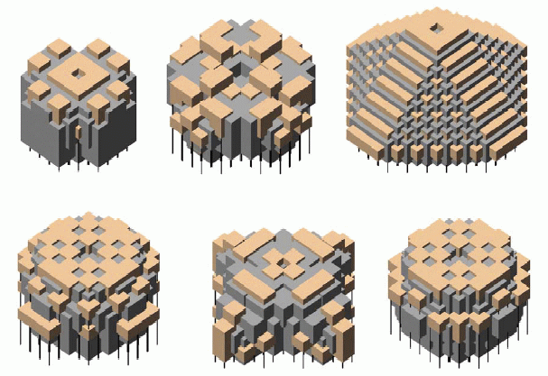
Disadvantages of CA in simulation applications:

- only discrete time steps
- some directions in space are preferred (due to the underlying grid)
- limited speed of interaction – no far-reaching, immediate effects possible

11.3 Grammars

Idea: Complex structures, e.g. the sentences of our natural language, can be described by simple rules.

For example, many sentences have the form:
Subject - predicate - object.

Definition:
A Chomsky grammar is a quadruplet
(Σ_{N}, Σ_{T}, X, R),
where Σ_{N} and Σ_{T} are disjunct sets of symbols, X ∈ Σ_{N} and R is a finite set of rules of the form A → B
where A and B are words over the alphabet Σ_{N} ∪ Σ_{T}
and A contains at least one symbol from Σ_{N}.
(after Noam Chomsky, American linguist and philosopher)

Symbols from Σ_{N} are called nonterminal symbols,
those from Σ_{T} terminal symbols.
X is the start symbol.

A derivation of a grammar is a sequence of words, beginning with X, where each word is obtained from its predecessor by replacing a subword according to one of the rules.
The language defined by the grammar consists of all words which can be derived from X and contain only terminal symbols.
Example:

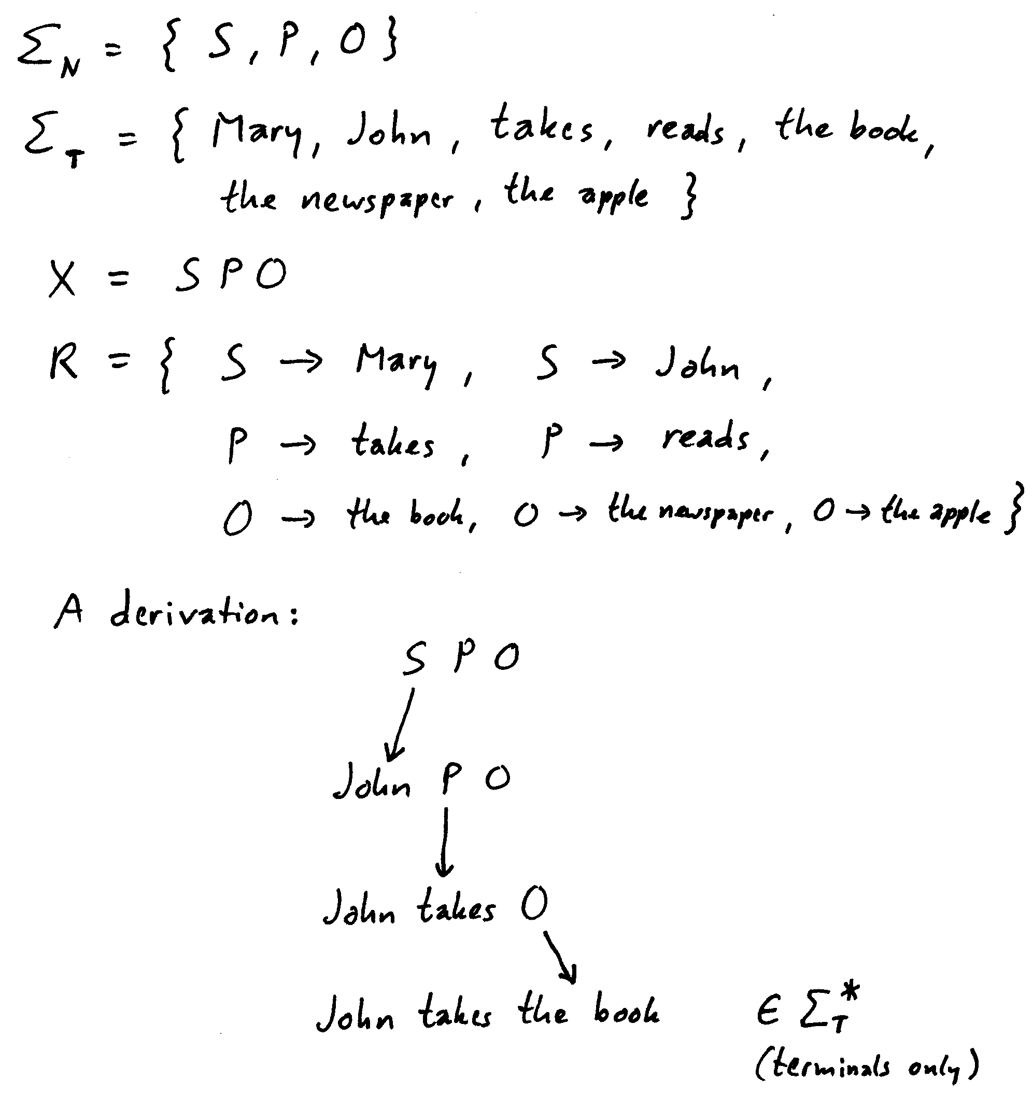

Applications:
- description of the syntax of natural languages
- precise definition of the syntax of programming languages
- use of grammar-based derivations as an alternative approach to problem-solving, particularly in Artificial Intelligence applications (automated theorem proving, decision-making, speech recognition, games...): rule-based programming paradigm
11.4 L-Systems

L-systems = Lindenmayer systems
(after Aristid Lindenmayer, botanist)

special sort of grammars
designed for modelling the shape of organisms,
particularly plants

Differences to Chomsky grammars:
- no distinction between terminal and nonterminal symbols
- only 1 symbol on the left-hand side of each rule
- all symbols for which a rule is applicable are replaced in parallel
- additional component: an interpretation which assigns a geometrical meaning to each generated word.

Formally:
(Σ, X, R, I),

where Σ is a set of symbols, X ∈ Σ and R is a finite set of rules of the form a → B
where a is a symbol from Σ and B a word
over the alphabet Σ
I is an interpretation mapping I : Σ* → R³ (from the set of words into 3-dimensional space).

normally used for the interpretation:
"turtle geometry"
"Turtle": device for drawing or constructing lines or cylindrical elements (virtual)
- stores (graphical and other) information
- has an internal "stack memory" (last in - first out)
- current state of the turtle contains information about current line thickness, step length, colour to be used, further properties of the object which will be constructed next

Turtle commands (selection):

F "Forward", including construction of an element
(line segment, internode of a plant...)
uses the current step length as the length of the new
segment

f forward without construction ("move" command)

L(x) change the current step length to x

L+(x) increment the current step length by x

L*(x) multiply the current step length by x

D(x), D+(x), D*(x) analogous for thickness
(diameter of the next segment)

RU(45) Rotation of the turtle around the "up" axis by 45°

RL(...), RH(...) analogously around the "left" and
"head" axis

up-, left- and head axis form an orthonormal
system with positive orientation which is carried
by the turtle

+, – abbreviations for RU(ϕ) and RU(–ϕ) with fixed angle ϕ

Branching: Realized with "stack commands"

[ put current state on the stack memory

] take the state from the memory which was
just put there and make it the current state of the
turtle (finishes a branch)

Example:

Rules

a → F [ RU45 b ] a,
b → F b

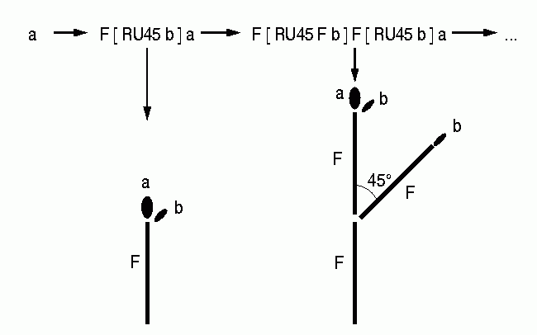
Start word a

(a and b are normally not interpreted geometrically.)

Further examples:

\angle 25.7,
F → F [ + F ] F [ – F ] F

Result after 7 steps:

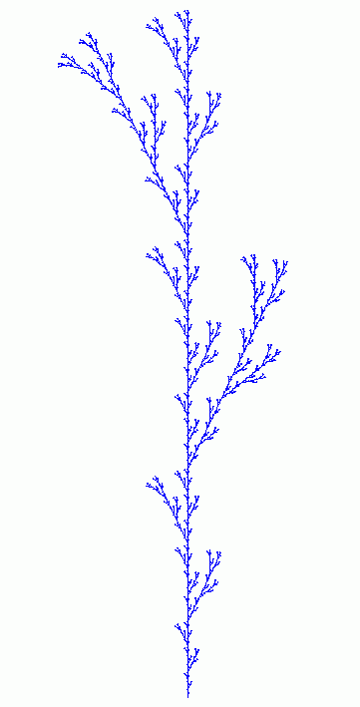

Branching, alternating orientation of branches and progressive shortening (like in real plants):

* → F a,
a → L*0.5 [ RU90 F ] F RH180 a

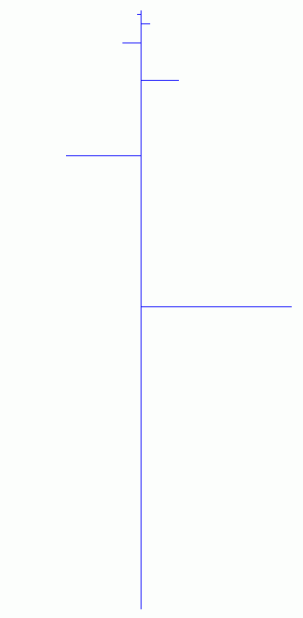

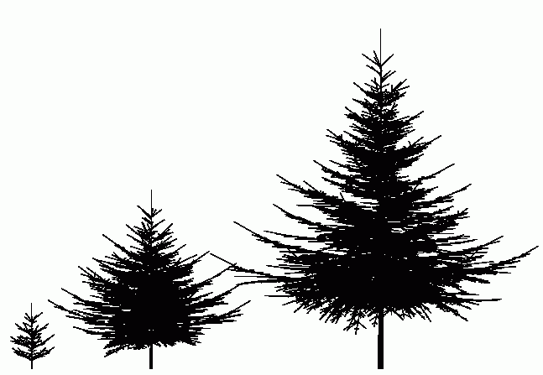
Examples of real-world vegetation modelled with L-systems:

spruce trees
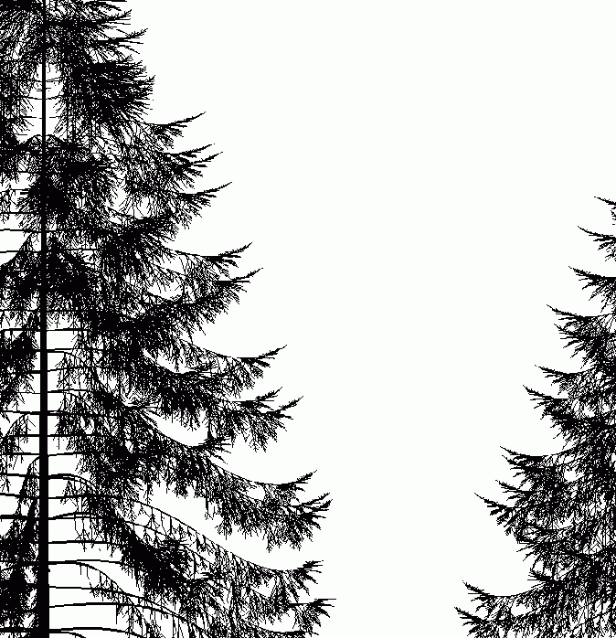
Example mint (by Prusinkiewicz & Lindenmayer):

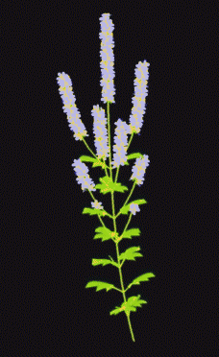
Beech twigs:

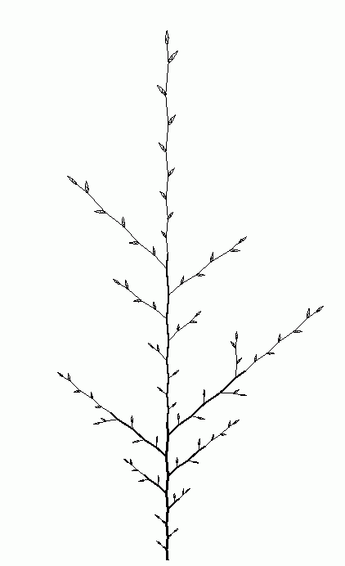 | 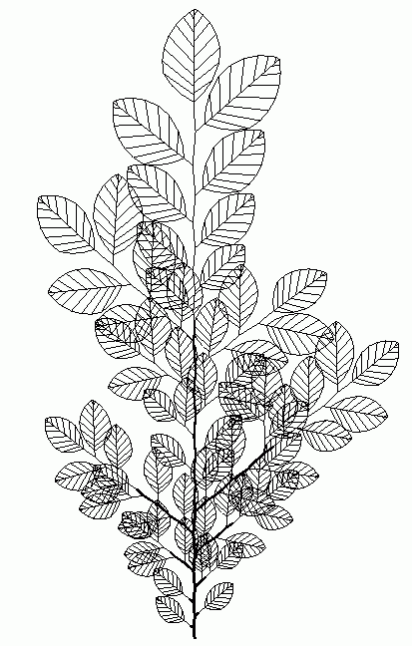

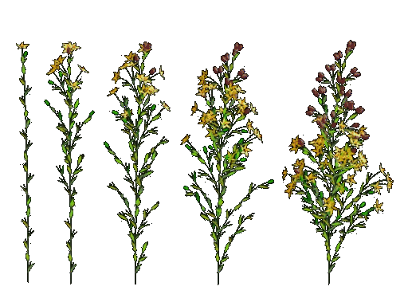
Development of flowering plants:

