9. Databases

Motivation:

Computers are often used
- for dealing with large amounts of data
- and in situations where data integrity is important for the survival of an organization.

Examples:

- Banking
- e-commerce (commercial transactions via WWW – e.g., amazon.com or ebay.com)
- meteorological measurements
- booking systems (trains, airlines...)
- ERP systems (Enterprise resource planning)
- telecommunication (phone numbers, fax numbers, mobile phone data...)

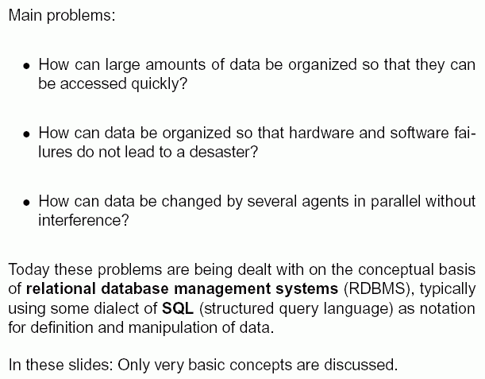
Introduction using an example

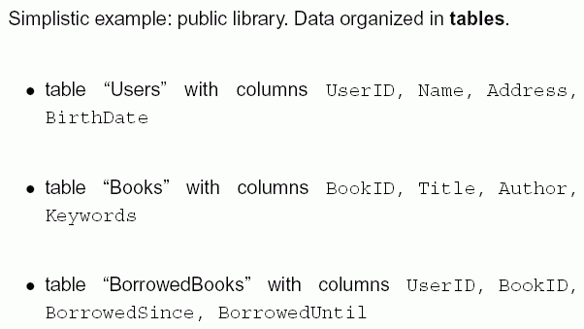

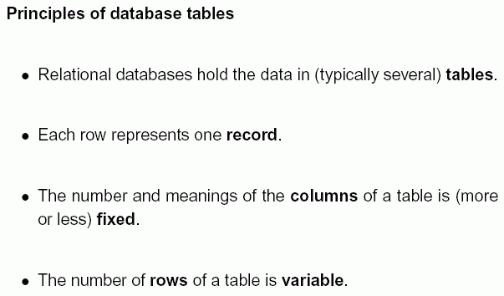

"Entity relationship model":
- Each table describes one kind of entities or a relation (typically between several entities)
- a model of a certain part of reality based on the concepts of entities and their relationships is called an entity-relationship model.
In our example: tables "Books", "Users" represent entities,
table "BorrowedBooks" represents a relation between these entities.
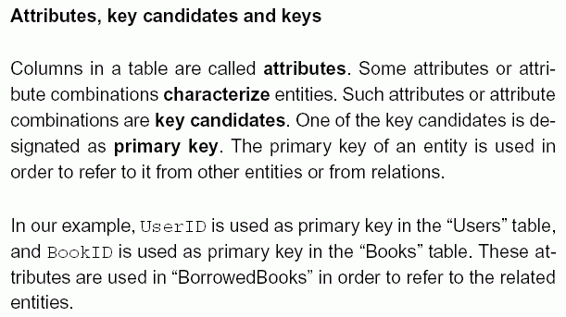

Data definition and data manipulation with SQL

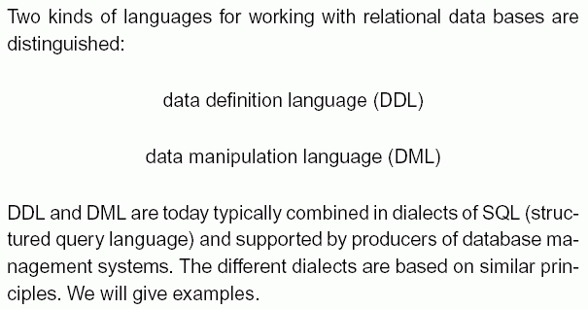

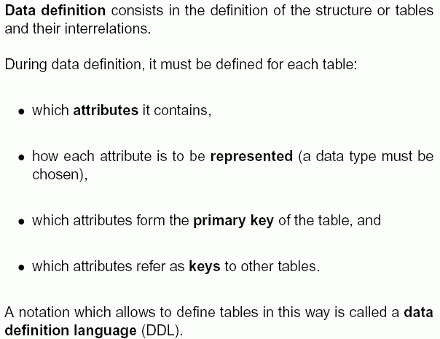

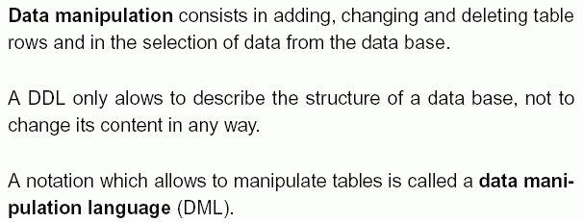

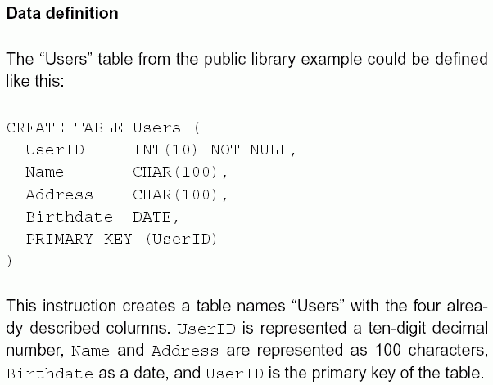

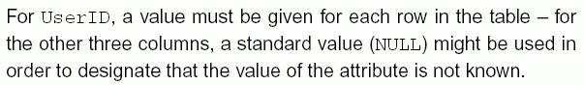

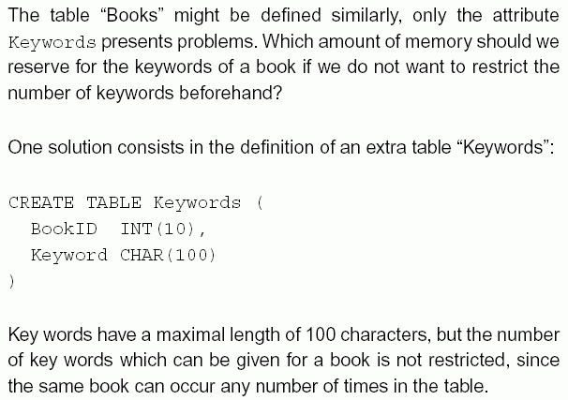
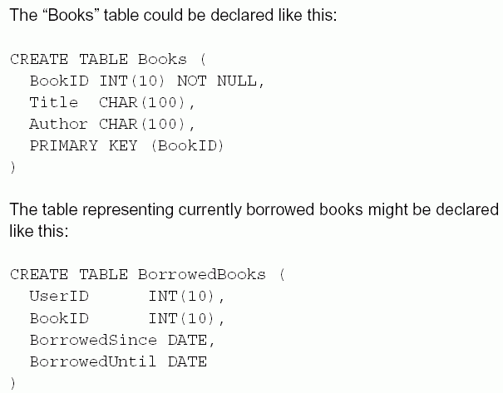

Data manipulation

The following operations can be used to manipulate the data in the tables:

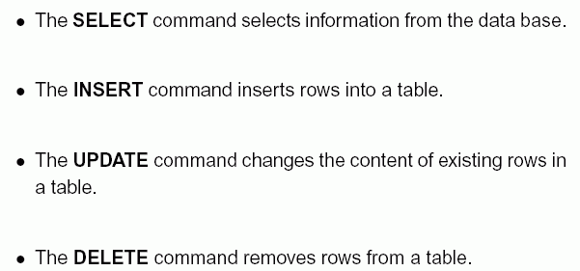

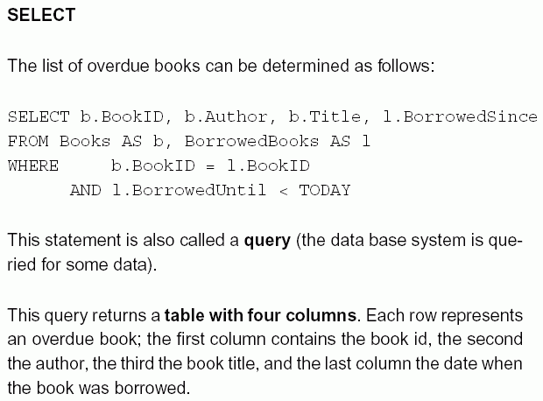

A query has the following form:

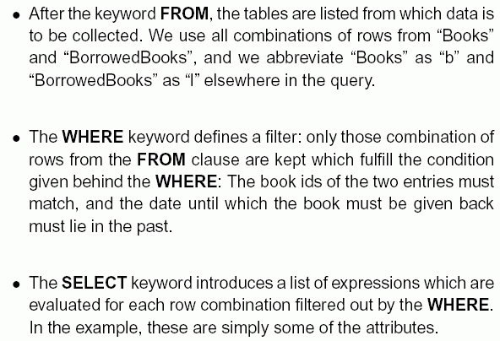

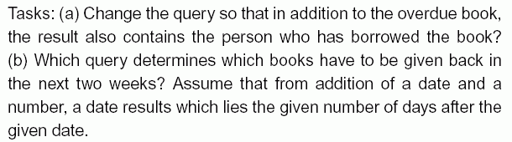

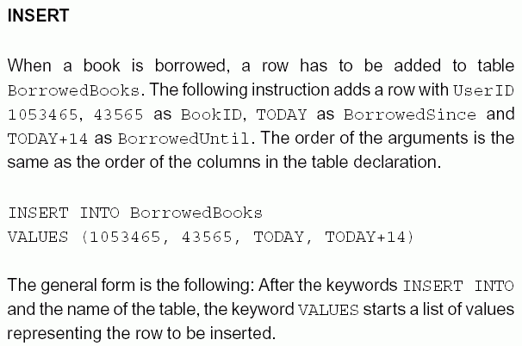

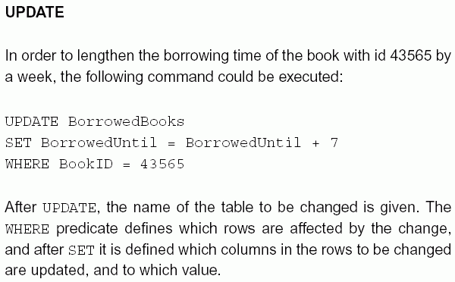
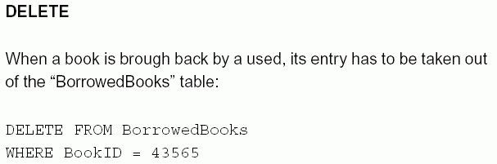

Further elements of the SQL language

Above we have only seen the most elementary SQL language elements. Many SQL dialects present many more features. Examples:
- Integrity constraints can be used in order to define conditions on the content of a database which shall never be violated during manipulations.
- Foreign key relations are used in order to make explicit that values in a column are keys of some other table. They are a special case of integrity constraints.
- Index declarations are used in order to accelerate searching in tables.
- Stored procedures are used in order to store instructions which are to be executed by the database.
- Further table operations: set union, set difference, set intersection, grouping of results, sorting of results.
- Views allow to shield the users of a database from the internal representation of the data.
- Database administration consists in deciding how tables etc. are represented and which users get which kind of access to the database.
- Invariants and triggers are language elements which ensure the fulfillment of integrity constraints independently of the application programme.
- Transactions are language elements which ensure that a sequence of changes is either executed completely or not at all, even in the case of hardware or software failures.

Conceptual database design

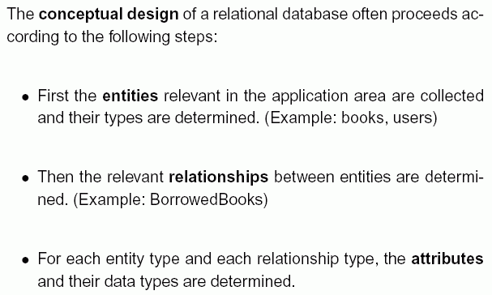

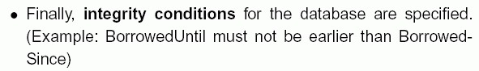

On the basis of this design it is decided how entities, relationships, attributes are represented in a specific database management system.

Normalization:

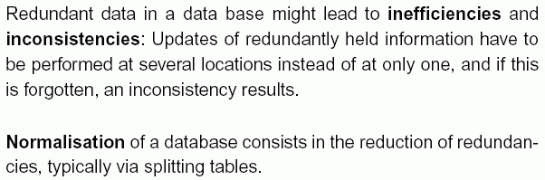

Architecture of database applications

Database applications often use a three-layer architecture:

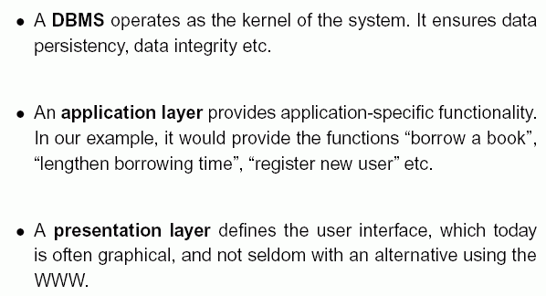

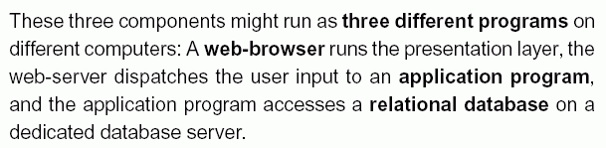

Geographical Information Systems

What is a Geographical Information System (GIS)?

- Software, hardware and data to help manipulate, analyse and present information that is tied to spatial locations (usually geographical locations).

Estimates are that 80 % of all data stored worldwide has a spatial component (Source: www.gis.com).

A GIS contains a classical database, but extends its functionality by methods adapted to spatial information.

Particularly, a GIS provides...

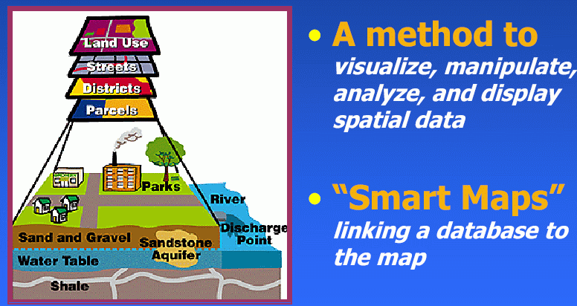

- special forms of query, designed to extract information with spatial properties from a database (e.g., taking neighbourhoods into account)
- special forms of data analysis (e.g., geostatistics)
- special forms of integrity checking adapted to spatial data.
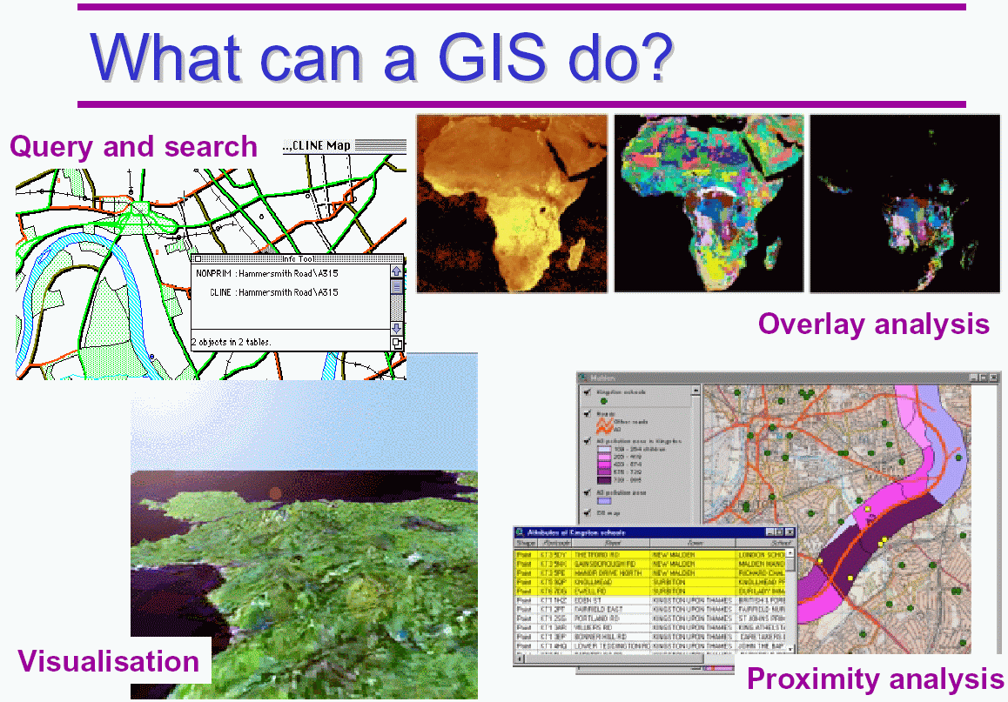

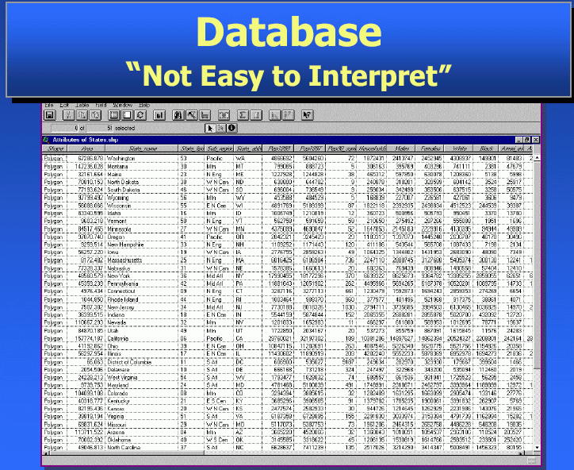
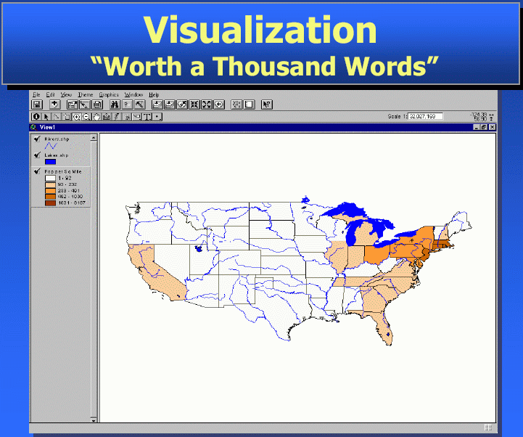

One of the main advantages of GIS over classical geographical maps:

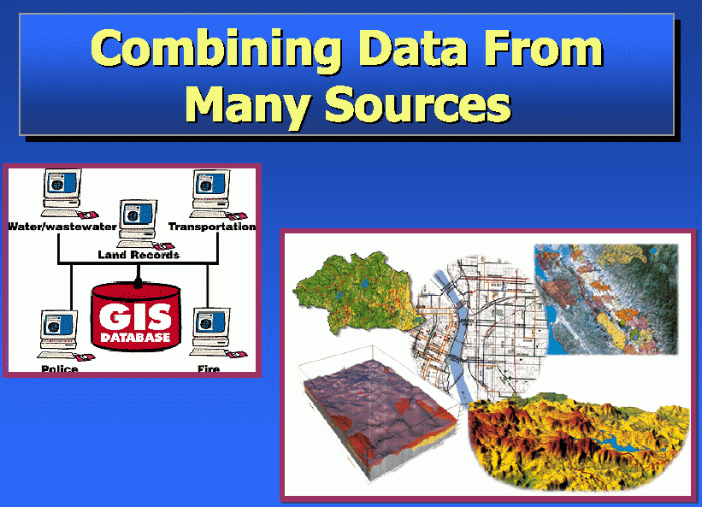

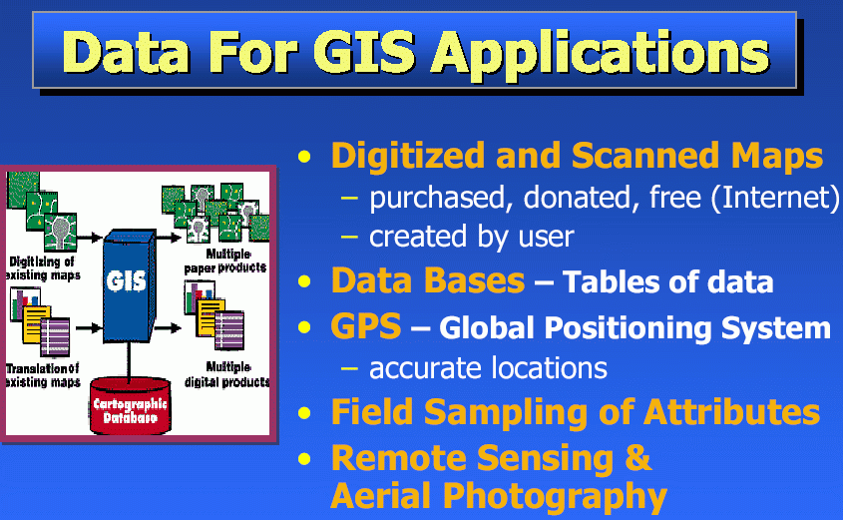

Further advantage: Easy interaction, visualization, manipulation of maps

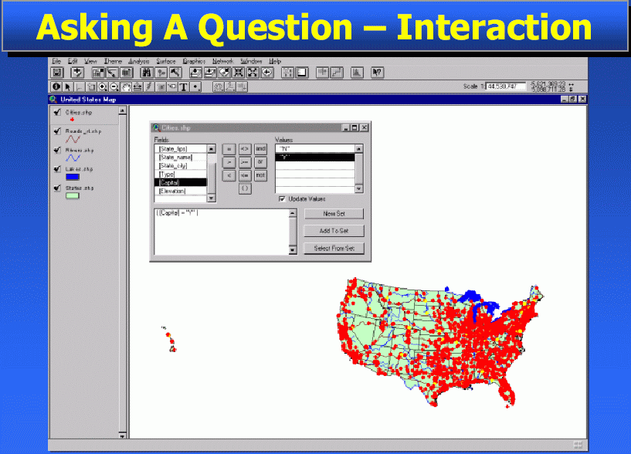

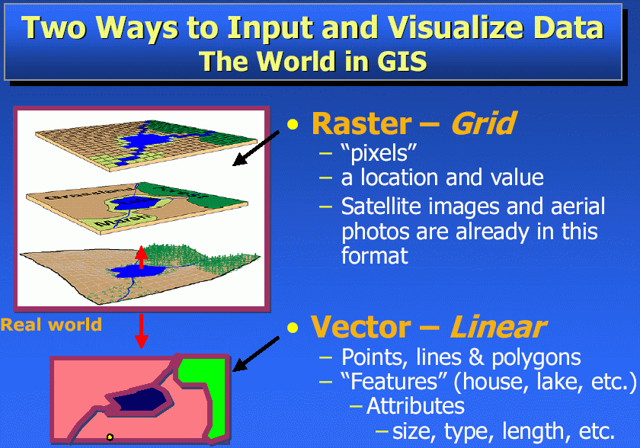

The vector representation is more appropriate for senseful queries (and is more exact)
– basis for relational database representation of geographical data

Typical entities of a GIS:

Points
- Tics (= special points for which the exact real-world coordinates are known, used to fit a digital map into a global coordinate system)
- Lines, also called arcs (more precisely: Multilines, i.e. consisting of several linear segments)

- Polygons (closed multilines, possibly with additional attributes)
- Annotations (text objects associated with points).
The endpoints of a line (and possible branching points) are called nodes.
Intermediate points (without branching) are called vertices.

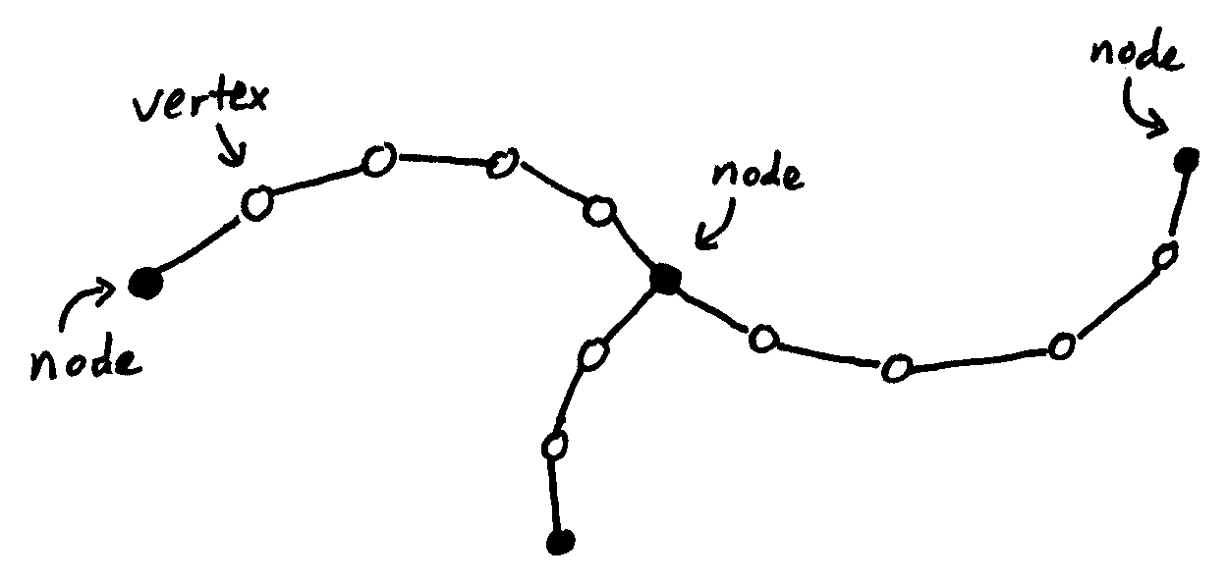

Tables in the underlying relational database:
- Tic table
- boundary table (represents the spatial extent of the map – a surrounding rectangle)
- arc attribute table (AAT)
- polygon attribute table (PAT).

E.g., a polygon is represented as a line in the PAT, with attributes: polygon ID, nodes, arcs, a label point (in the interior), further attributes (e.g., area, slope, population density...). Details differ between different GIS.

Usually, a GIS does not only contain information for a single map of a region, but several sorts of information for the same region:

each sort of information is represented in an extra coverage (also called layer, cover or theme).

Example: Different coverages of a town area:
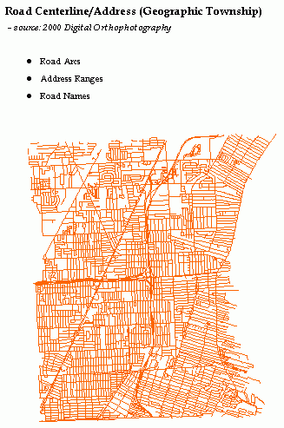 | 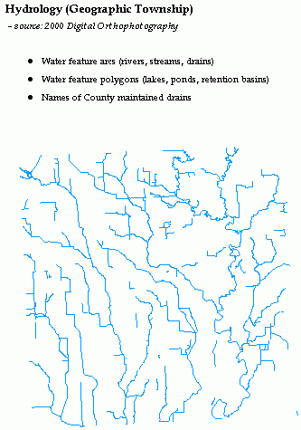
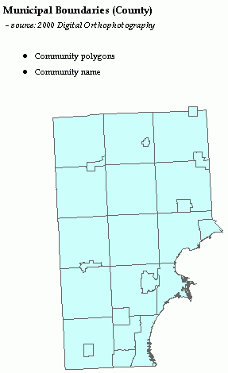

(source: http://macombcountymi.gov/gis/
gis_coverage_samples.htm)
How to combine several coverages?

- Overlay operation

From two geometries, the GIS calculates the coarsest common geometry:

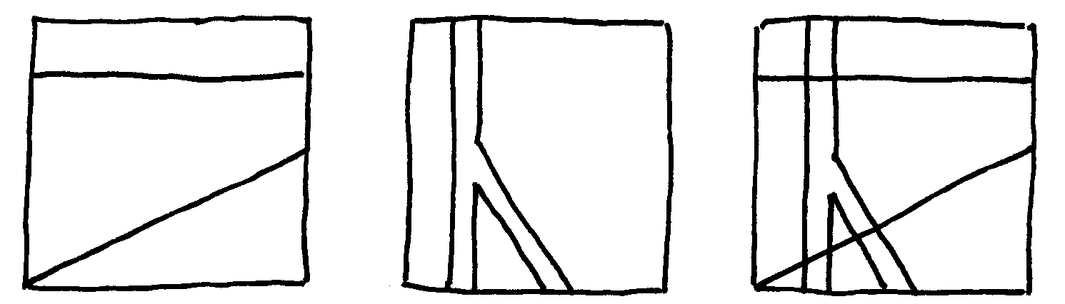
a b overlay of a and b

Attention: The following geometry 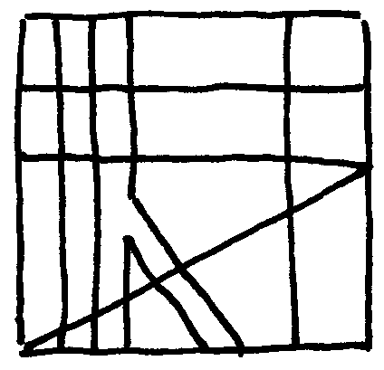 would also
be a common geometry of a and b, but not the coarsest one!

Using overlay, a GIS can give answer to questions like:
"What forest areas of district x are within 100 m distance to a road, are stocked with conifers and have a slope < 5 degrees?" (e.g., for a chalking action)

Layers used for this task:
- landuse map (→ forests)
- political district map (→ district x)
- road map (→ 100 m neighbourhood to a road)
- forest type map (→ stocked with conifers)
- digital elevation model (→ slope < 5 degrees)

Selection of polygons of the overlay using an "and" operation

Further functionality of GIS: 3D visualization

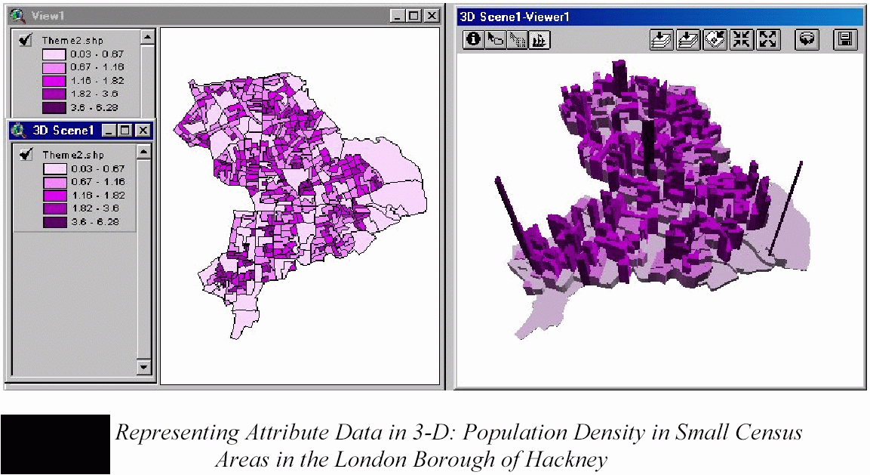

Widely used GIS products:

- ESRI ArcView, ArcGIS (licenced commercial software)
- FreeGIS (open source, www.freegis.org)

