7. Time complexity of algorithms

"Complexity" can have different meanings.

In computer science most often:
"time complexity" = amount of calculation time which an algorithm needs
"space complexity" = amount of memory which is needed by an algorithm

Algorithms solving the same problem can behave very differently:

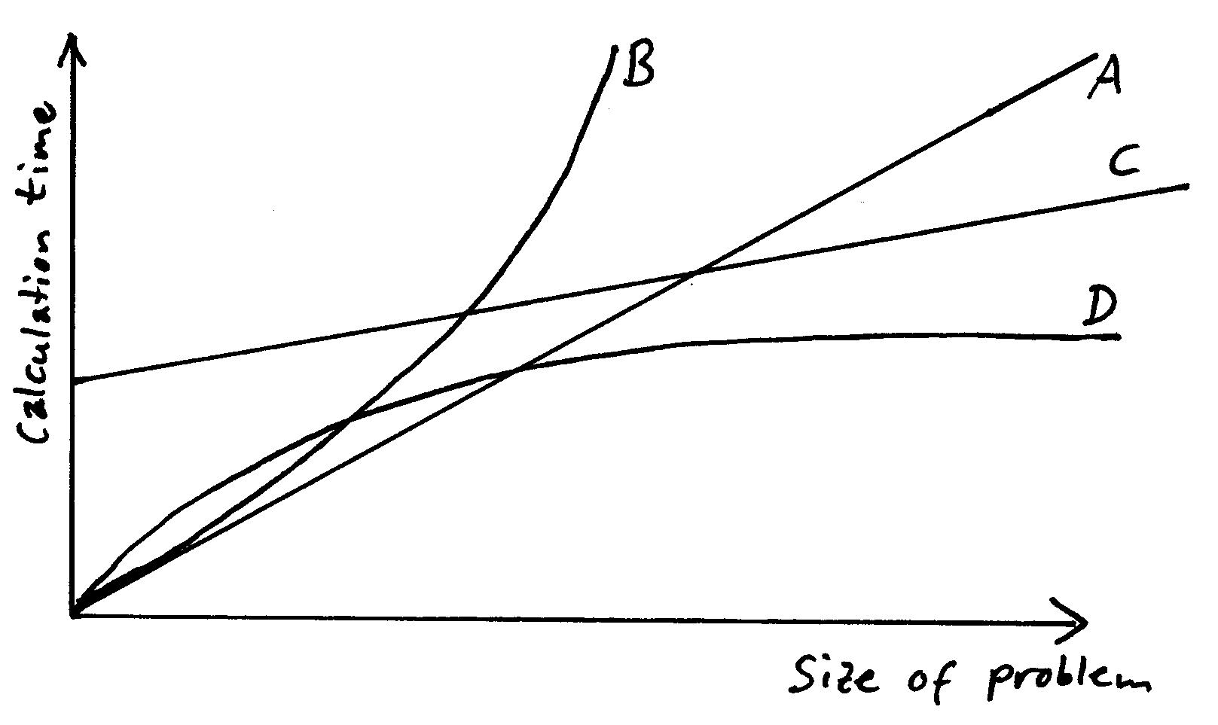

Algorithm A needs an amount of time proportional to the size of the problem (input size) – it "scales linearly"

B has nonlinear behaviour and is worse than A

C: linear, worse than A for small problem size, but better for large problem size
D is even better for large problems
How to make these considerations more precise?

What shall be measured?

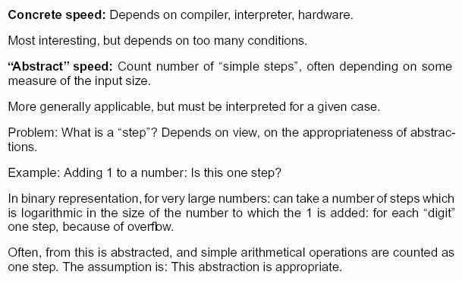

"size of input" as parameter – but input can be very different, even if it has the same size
(e.g., array of numbers: sorted or unsorted)

Variants of time complexity:

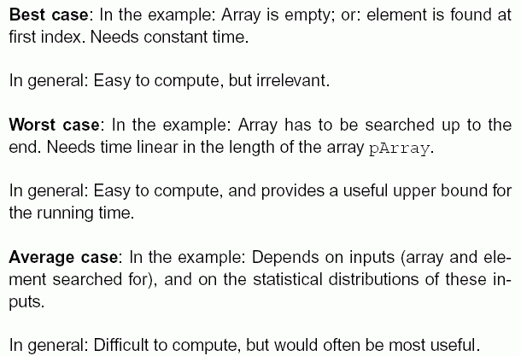

How to describe different "growth forms" of functions?

→ Bachmann-Landau "O Notation" (uppercase "O", not a zero!) — for short: O calculus

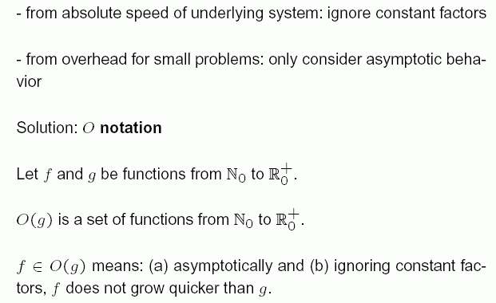

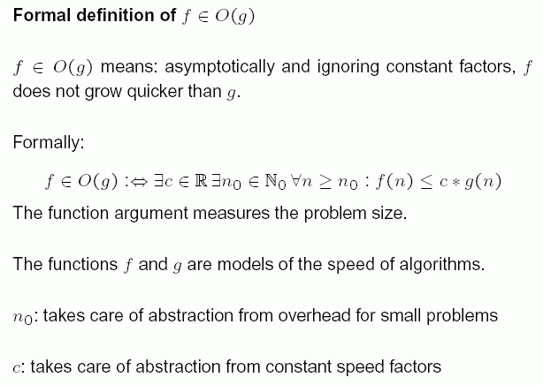
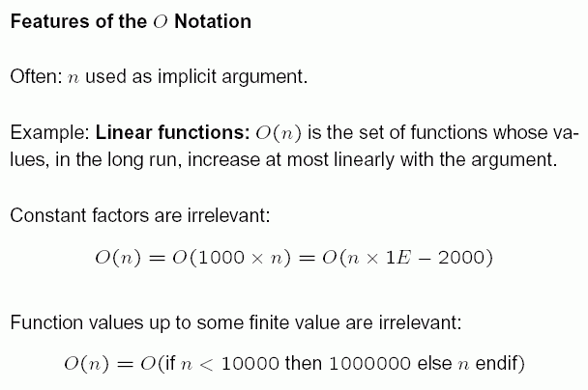

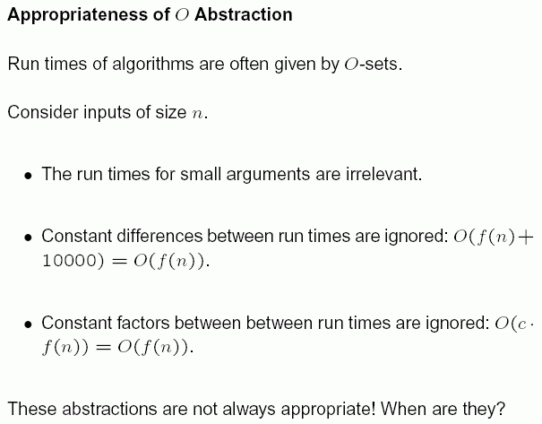

Important classes of algorithms, according to their runtime behaviour:

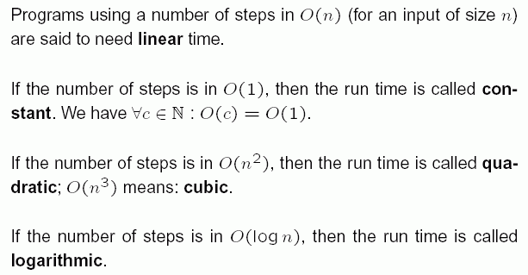

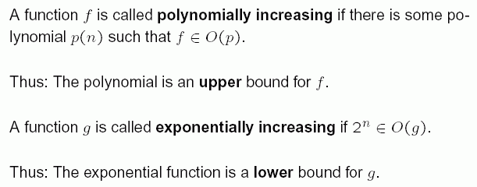

Computation rules for the O notation

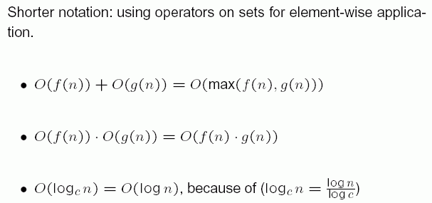
Example:

Analysis of a search algorithm

Given:
- an unsorted integer array, pArray.
- a single integer, pElem.
Wanted:
the first index i where pElem is found as an element of the array (i.e., pArray[i] == pElem).
If it cannot be found: result –1.

Algorithm: Sequential (or linear) search.

Goes step by step through the array, starting with i=0.

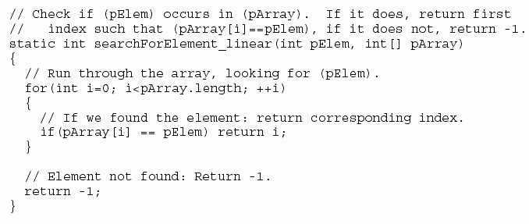

Analysis of this algorithm:

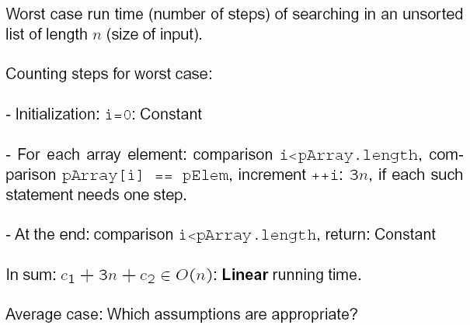

Let us now assume that the array pArray is already sorted, i.e., the elements have ascending order:
pArray[0] <= pArray[1] <= pArray[2] <= ...

Then we can use the same algorithm as above
- but we can do better:

Algorithm: Binary search

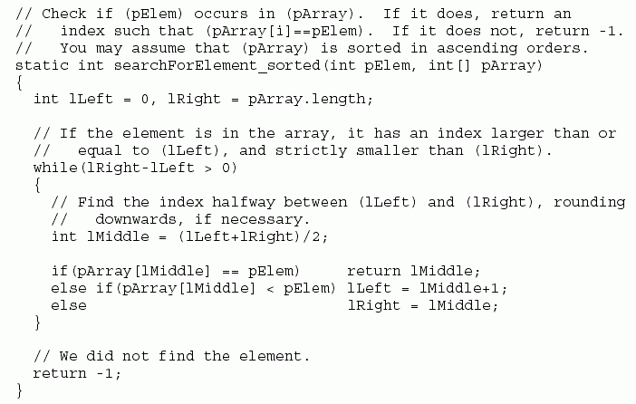

Example: we look for the number 11 in the following array:

i | 0 1 2 3 4 5 6 7 8 9 10
pArray[i] | 1 2 4 6 7 8 10 11 13 17 19

go first to the central index, lMiddle
(0+10)/2 = 5, there we have 8 < 11 ⇒ go to the right
there look again at the central index:
((5+1)+10)/2 = 8, there 13 > 11 ⇒ go to the left,
split again the array... until 11 is found

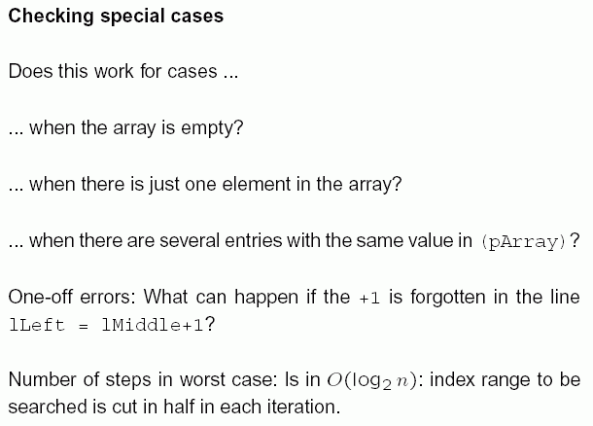

Further example: Two sorting algorithms

Task: To bring the elements of an unsorted integer array in ascending order

(sorting into descending order can then be done in analogous way!)

How to solve it?

Idea: bring the largest element to the leftmost position by pairwise exchanging neighbouring elements
repeat this in the still unsorted first part of the array

→ effect: the large elements go like "bubbles" through the array to their appropriate places

Algorithm "Bubble sort"

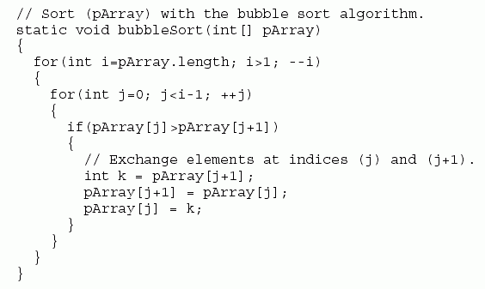

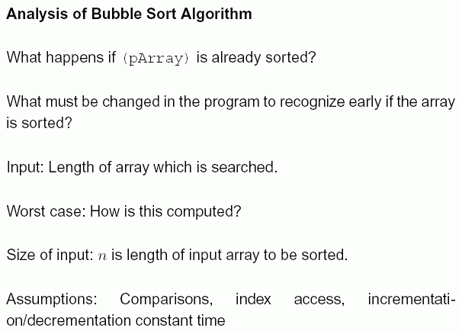

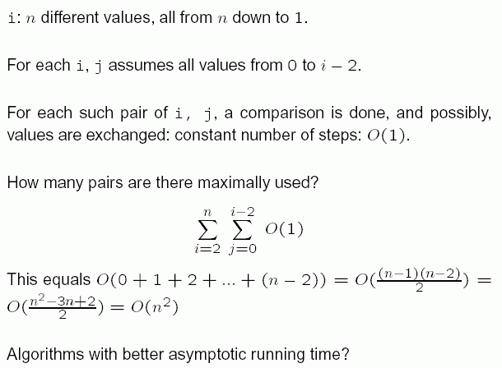

Idea: Use binary splitting of the array, like in the case of binary search

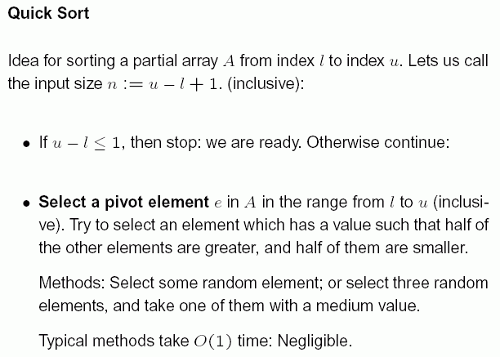
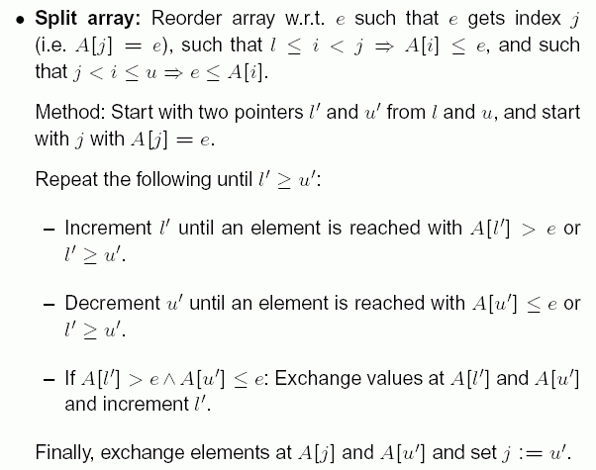
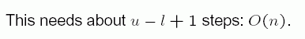

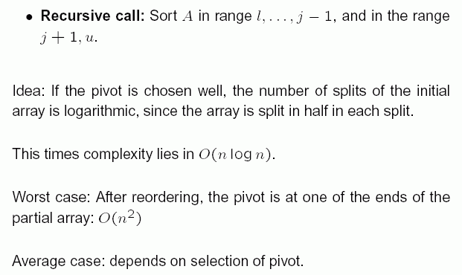

Remark: There is still another sorting algorithm which needs only O(n log n) time even in the worst case (Heap sort).

