6. Fundamentals of programming

From a problem to the solution

First considerations when for a problem a programme shall be designed:

WHAT – HOW – WITH WHAT

WHAT (which goal) shall
HOW (with what means) and
WITH WHAT (with which instruments) be achieved?

WHAT: problem specification

functional specification:
- input / output and their interrelation,
- formal-mathematical and informal description

specification of requirements:
- ways of usage
- usage rights
- duration of use
- security requirements
- financial context
etc.

HOW:

- algorithm
- structure of programme
WITH WHAT:

- hardware (computer, periphery, other technical equipment)
- software (operating system, programming language, development toolkit, programme libraries, ...)

14 steps from the problem to a solution:

1. Problem
2. Mathematical formulation
3. Finding an algorithm A which solves the problem
4. Formulating A
5. Precise formulation of A
6. Proof of adequatness of A
7. Coarse programming
8. Choice of programming language and computer
9. Fine programming
10. Programme verification
11. Test of the programme
12. Calculation
13. (possibly) generalisations
14. (possibly) implementation as subprogramme or as
part of a programme library

A simple example:

1. Problem:
In a gear mechanism, the driving cogwheel shall move two other cogwheels, one with a cogs (e.g., a = 105) and one with b cogs (e.g., b = 147). A full turn of each of the driven wheels shall correspond to one or several full turns of the driving wheel, and the gear ratios should be as small as possible. How many cogs must the driving wheel have?

2. Mathematical formulation

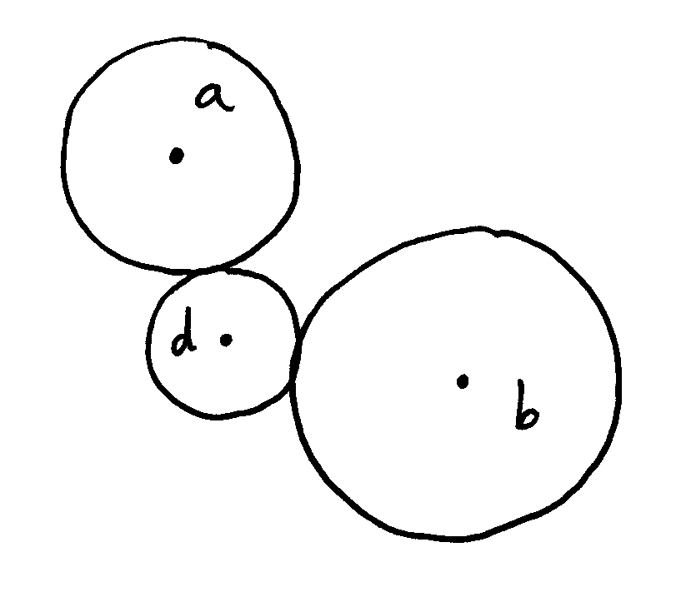 | Let d be the number which we are looking for. Then, obviously, the following must be fulfilled:  d divides a and d divides b.  Because the gear ratios shall be as small as possible, d must be maximum, thus d = greatest common divisor of a and b ( gcd(a, b) ).

3. Finding an algorithm which solves the problem:

Euclid of Alexandria (around 325 B.C., "Elements", book 7, problem 1, proposition 2); probably already found by Eudoxos of Knidos around 375 B.C.:

"Euclid's Algorithm"
147 : 105 → 1 rest 42
105 : 42 → 2 rest 21
42 : 21 → 2 rest 0
gcd(105; 147) = 21

4. Formulating the algorithm:

I. If a ≠ b, let x be the greater and y the smaller one of the
numbers a, b;
in the case a = b let x = a = y.
II. Calculate x/y with rest.
III. If there is no rest, we have y = gcd(a, b).
IV. If there is a rest r, replace x by y and y by r and go to II.

5. Precise formulation of this algorithm:

Let a, b be positive integers and without loss of generality
b ≤ a,
furthermore x₀ = a, x₁ = b and x_{n–1} = q_{n}x_{n} + x_{n+1}
with q_{n}, x_{n+1} ∈ {0; 1; 2; ...}
and x_{n+1} < |x_{n}| for n > 0 and x_{n} ≠ 0.
Let n be the first index with x_{n+1} = 0. Then x_{n} = gcd(a, b).

6. Proof of adequatness of the algorithm

First to show: The algorithm specified above terminates, i.e. there is always an integer n such that x_{n+1} = 0.
This holds because of x_{n+1} < x_{n} and x_{n+1} ≥ 0: There exist only finitely many integers between x_{n} and 0, hence only finitely many steps.

Furthermore, we have
x_{n} divides q_{n}x_{n} + 0 = x_{n–1}
x_{n} divides q_{n–1}x_{n–1} + x_{n} = x_{n–2}
x_{n} divides q_{n–2}x_{n–2} + x_{n-1} = x_{n–3}
...
using the "complete induction principle", we can conclude:
x_{n} divides q₂x₂ + x₃ = x₁ = b
x_{n} divides q₁x₁ + x₂ = x₀ = a
hence x_{n} divides the integers a and b and thus also gcd(a, b).

On the other hand, the gcd is a divisor of x₀ and x₁ and according to the above chain of equations also of x₂, x₃, ..., x_{n–1}, x_{n}.

Hence x_{n} = gcd(a, b), and this was to be proved ("q.e.d." = "quod erat demonstrandum").

7. Coarse programming:

Several methods and principles possible. Examples:

(a) Flowchart

Flow of programme written top-down and from left to right, if not specified otherwise by arrows.

First try:

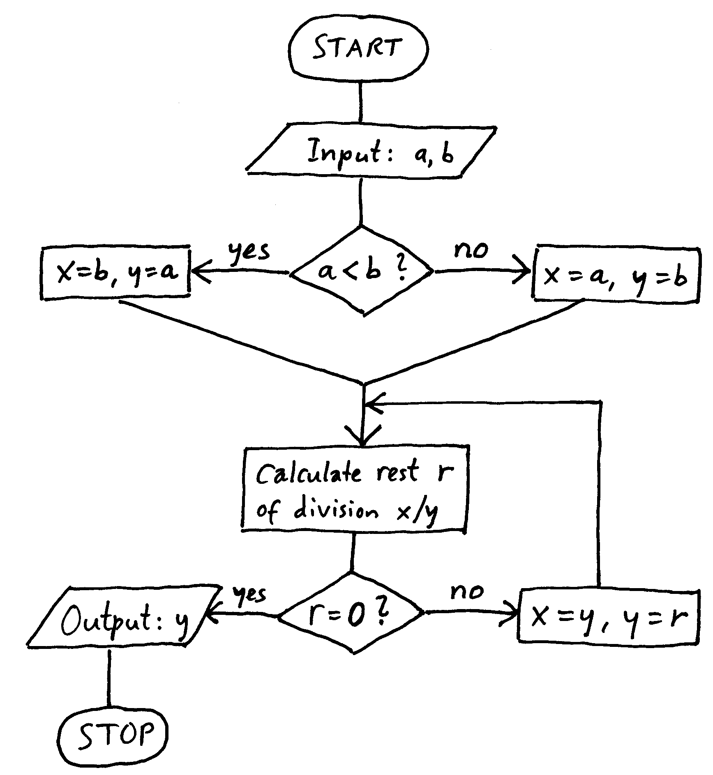

However, Euclid's Algorithm works also in the case b ≤ a, thus a simplification is possible, yielding:

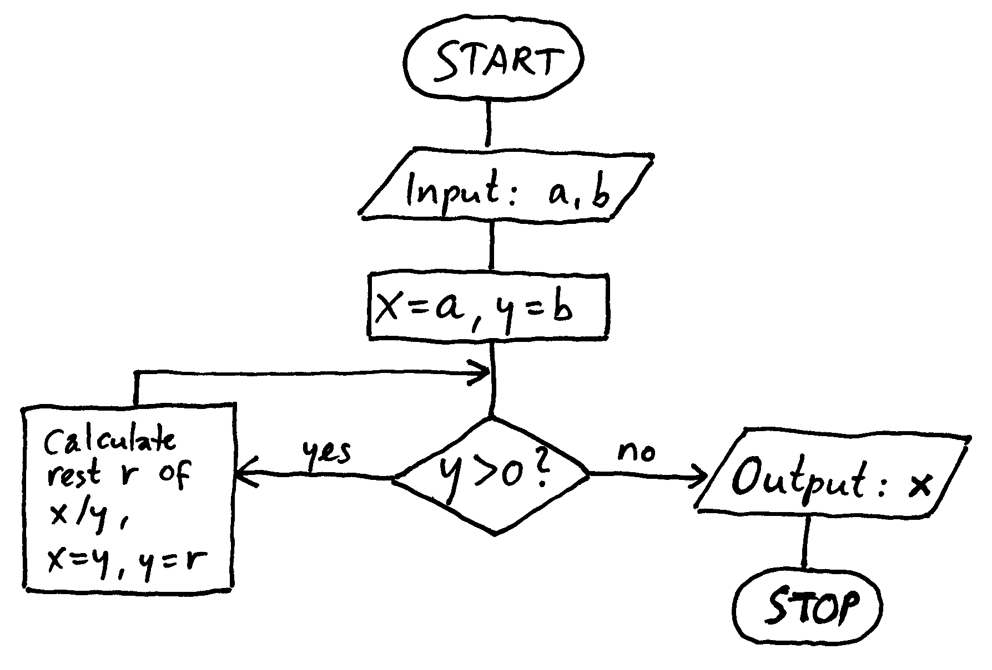

(b) Structogramme (Nassi-Shneidermann Diagramme),
corresponding to the second flowchart:

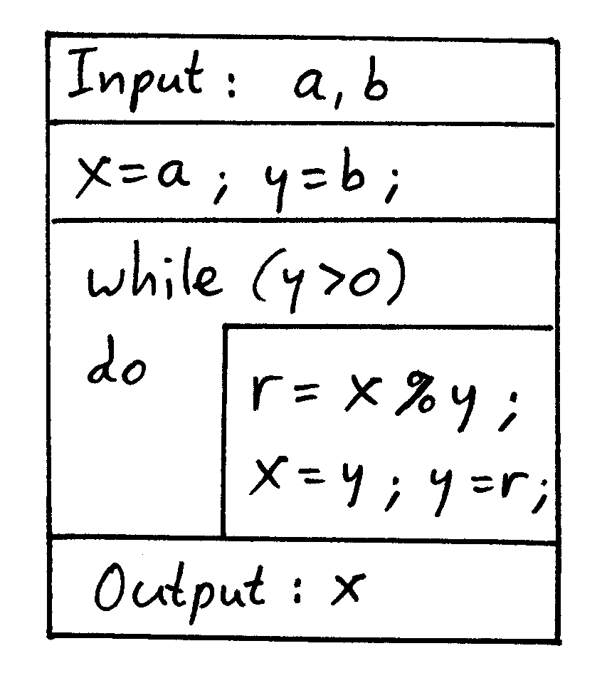

8. Choice of programming language and computer:

C on Intel-PC under MS-Windows

9. Fine programming:

#include <stdio.h>
int main()
{
char inbuf[50];
int x, y, r;
printf("\nTwo input numbers, please: ");
gets(inbuf);
sscanf(inbuf, "%d %d", &x, &y);
while (y>0)
{
r = x % y;
x = y;
y = r;
}
printf("\nResult: %d\n", x);
return 0;
}

10. Programme verification:

Checking the programme for correctness, i.e., if it does in every situation the right thing
- we must follow all manipulations of variables
Means: Assertions which must be fulfilled

Verification assertions
- after line 8: x, y positive integers (if correctly read!)
- after line 11: x = qy+r, q≥0, r ∈ {0; 1; ...; y–1}
- after line 12: x = y
- after line 13: y = r
- after line 14: y = 0
one has to check that these assertions remain fulfilled in each possible programme execution

11. Test of the programme

Tests using examples of number pairs with known result; try to do this in a way that all possible, qualitatively different situations are covered.
Particularly check all extreme cases (for example, something is = 0).

Examples:
30 40
100 100
0 100
100 0
100 1

12. Calculation

Input 105 147 → Output 21,
the driving wheel must have 21 cogs.

13. Possible generalisations, e.g., the gcd of arbitrary integers (up to now, we have only considered positive integers):

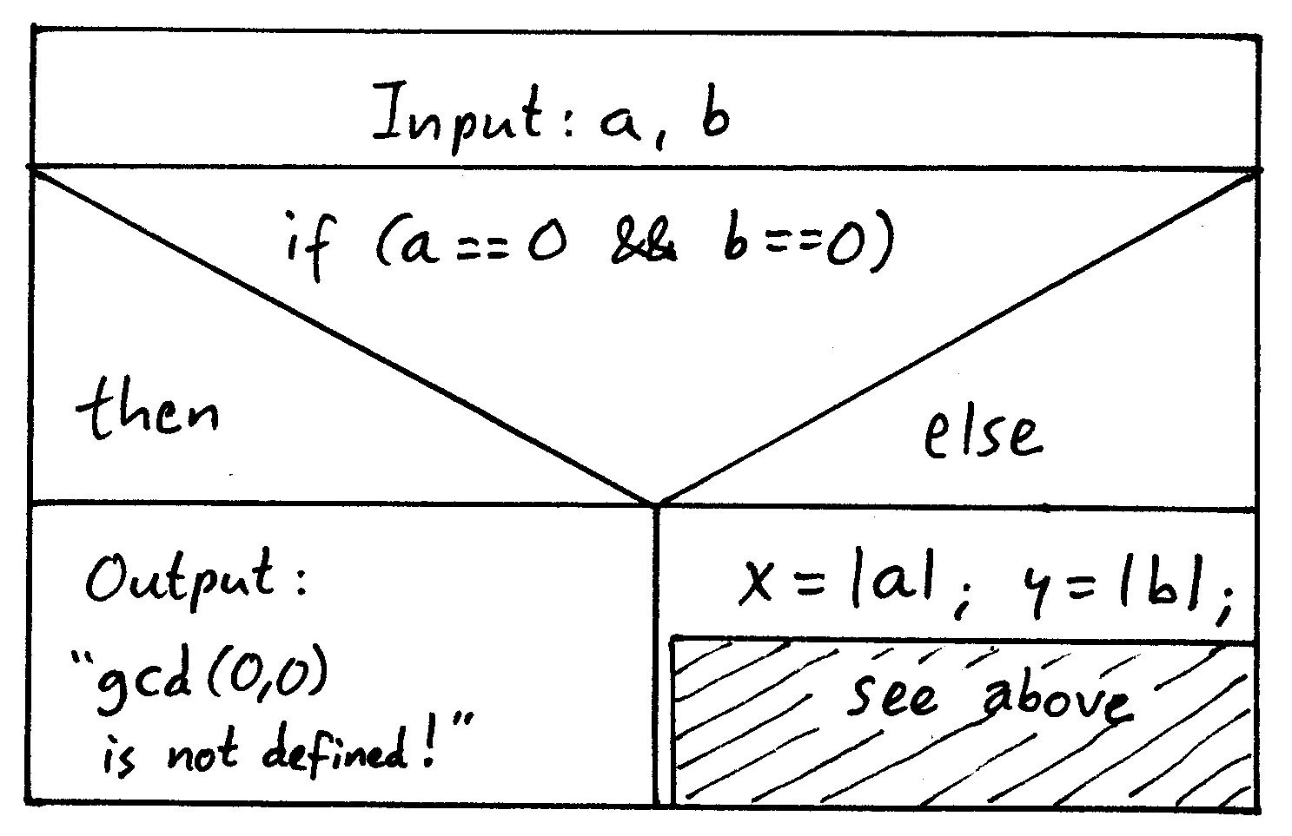

14. Possible implementation as a subprogramme
(function in C):

int gcd(int x, int y)
{
int r;
while (y > 0)
{
r = x % y;
x = y;
y = r;
}
return x;
}

this can be used in a larger programme – e.g.,
to calculate iteratively the gcd of more than 2 integers.

Possible call: z = gcd(p, q);
....

Simple Java programmes

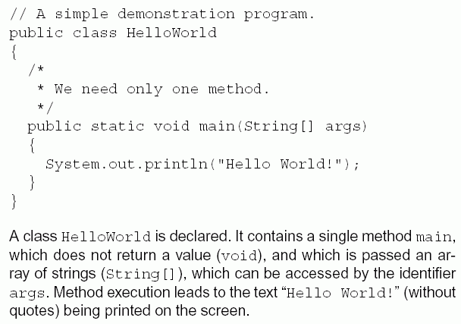
/* ... */ : comment (skipped by the compiler).
Alternative syntax for comments:
// .... (the whole line is skipped)

Terminology:

A class is a collection of data, together with appropriate operations on them.
In our example, HelloWorld, there is no data and only one operation, main.

A method is the definition of an operation, i.e., of something which can be done. Can be invoked by some (other) programme, or by the user.
In our example, the operation main prints a string on the screen.
Readability of programmes by humans

programmes: have to be executed by computers, but also to be understood by humans

Executability can be checked automatically, understandability not!

⇒ Recommendations:

- make frequent use of programme comments ( /* ... */ or // ... in Java)

- use plenty of newlines and blanks

- put braces { ... } in lines of their own, put matching braces in same horizontal position:
{
....
}

- indentation makes containment and nesting of programme components visible

- avoid long lines, insert line breaks for readability

- avoid very long methods

- use "speaking" variable and function names
(int iteration_counter is better than int x127 !)

- do not use variable names twice for different purposes, even if the language allows it

- Initialise constants, default values etc. at the beginning of a source code file, not somewhere "deep in the code" where you don't find them later on

- adhere to conventions used by competent programmers!
Essentials of Java

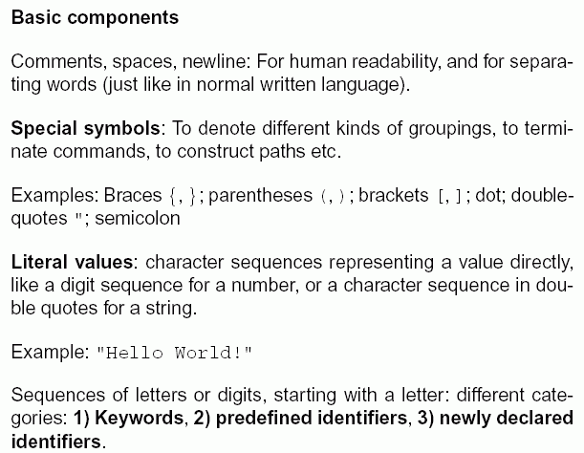

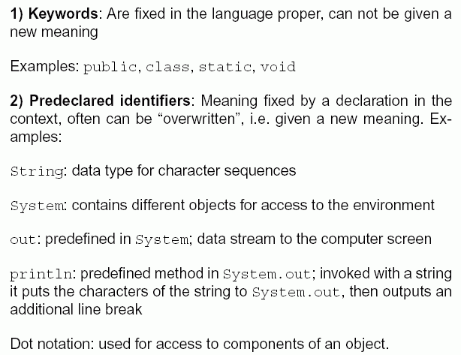
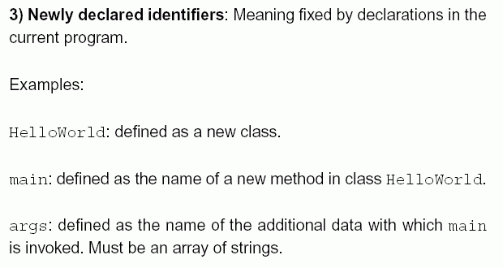

How to compile and run our example programme:

we use the JDK (Java Development Kit)
– containing command-line oriented tools for compiling and interpreting Java programmes. (The user gives commands to the computer as lines of text, the computer answers with lines of text.)

Needed for invoking the JDK: A shell, i.e., a programme which accepts lines of text from the user and outputs lines of text from programmes on the screen. Example: the "MS-DOS prompt" shell in MS-Windows.

The source code file name of the programme must be the same as the class name, with the file name extension .java appended.

⇒ our example programme must be placed in a file called HelloWorld.java .
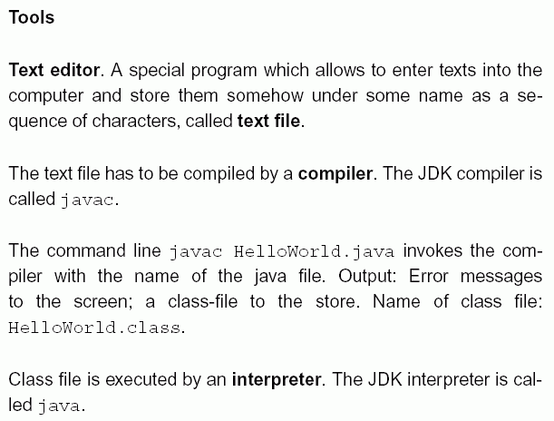

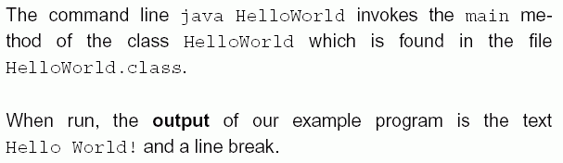

Use of simple data types and the "while" loop

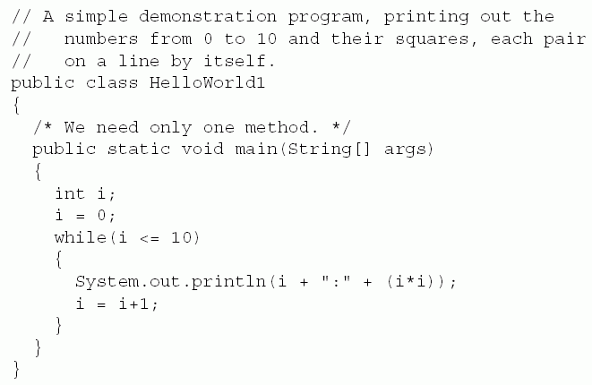

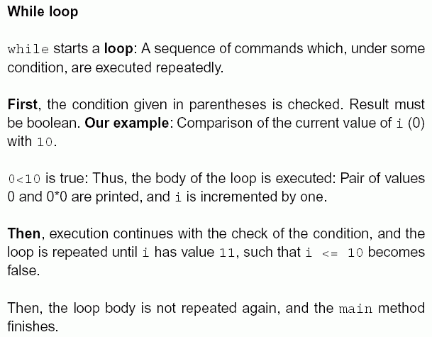
Assignments

in our example:
i = 0;
the variable named i gets the new value 0
- fundamental operation in the von Neumann programming paradigm

effect: content of a place in the memory is changed

Attention:
i = 0 in a Java programme does not have the same meaning as in a mathematical formula!
E.g., i = i+1 would mathematically be a contradiction
(it would imply 0 = 1)
– but makes sense in a programme (increment i by 1).
Mathematical meaning of this assignment:
i_{new} = i_{old} + 1.

In assignments, the order is relevant:
x1 = x2; has another effect as x2 = x1;

To underline the asymmetry, other languages (e.g., Pascal) use := instead of = for assignments

Comparison (checking for equality) is expressed in Java by = =

Java offers further assignment operators besides = :
a += b // add content of b to the content of a
–=, *=, /= etc. analogously.

Data types:

describe sets of values and the operations which can be performed on them.

Example: integers, with arithmetical operations (+, –, *, /, %) and comparisons (<, <=, >, >=, ...).

In the example programme:
String[], int, String, PrintStream.

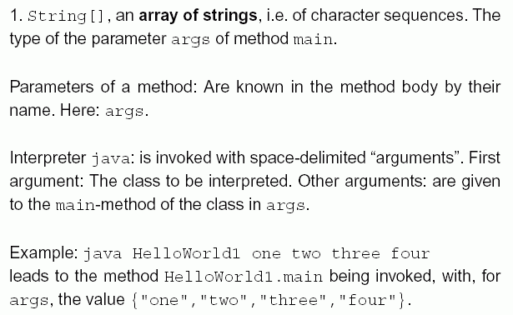

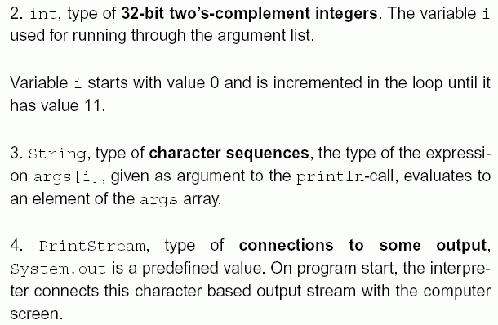

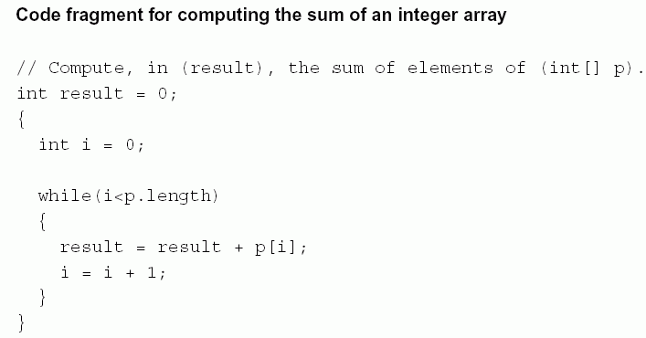

Ranges of declarations, visibility

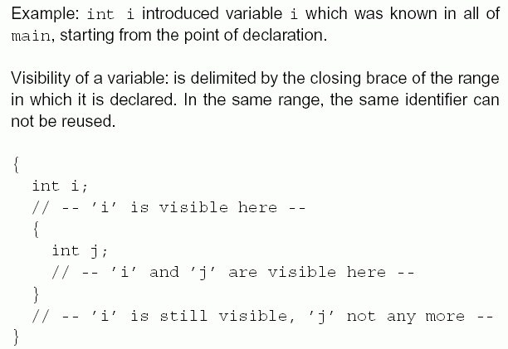

Literals

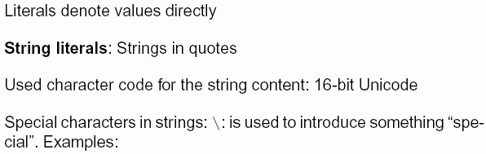

\uXXXX (XXXX: up to four hexadecimal digits):
The number of a Unicode character

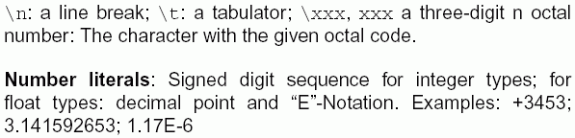

Primitive Java data types:

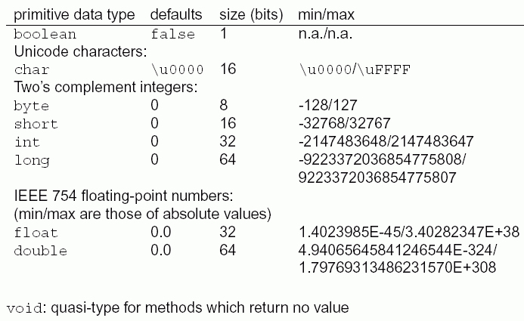

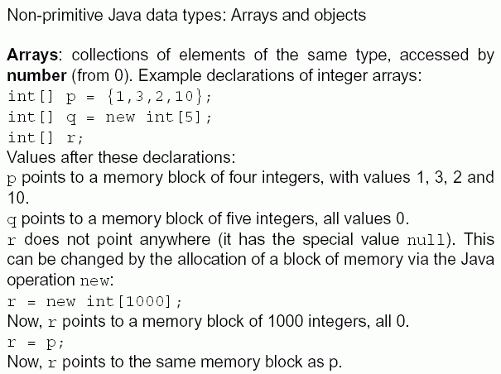

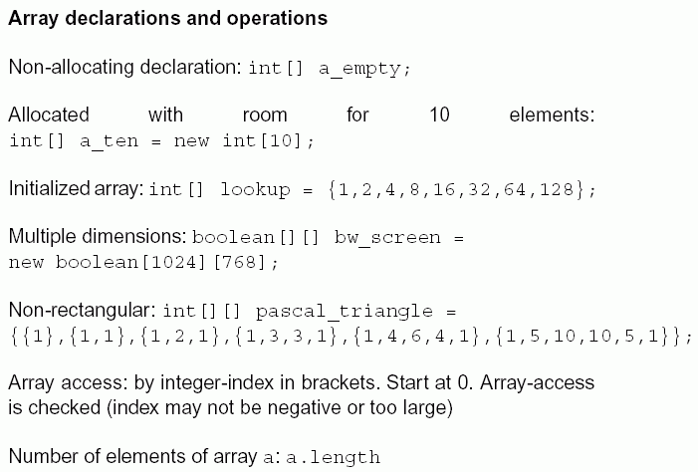

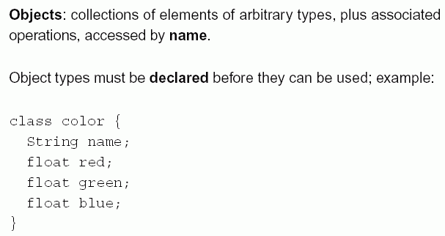

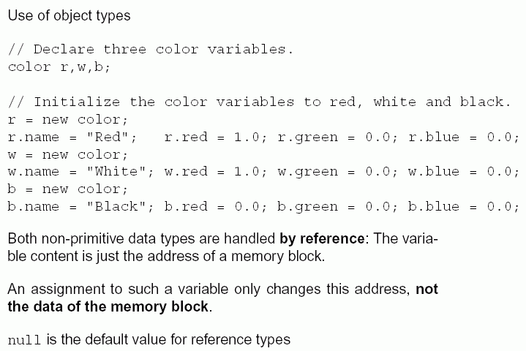

Java operators

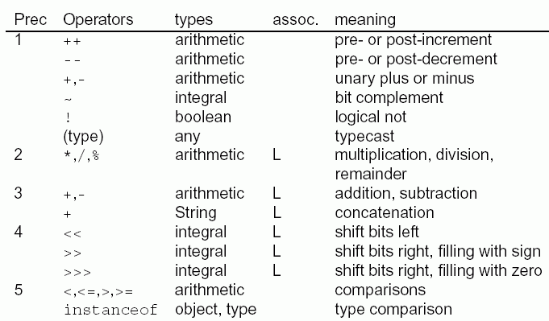
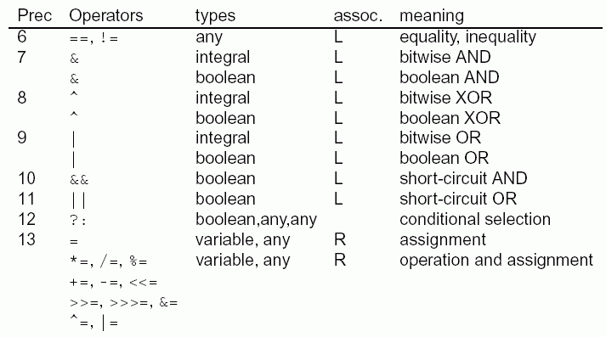

("assoc" = order of association, i.e., evalutation from left (L) or right (R) when several operators of the same level occur in the same expression)

Functional abstraction, self-defined methods

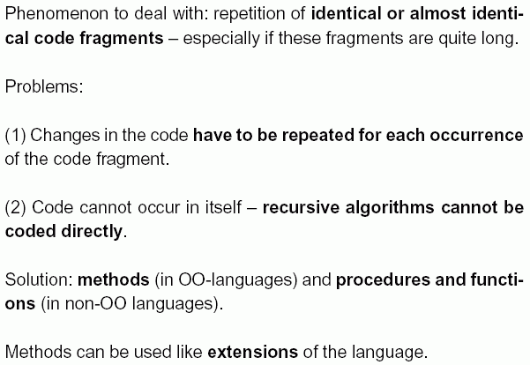

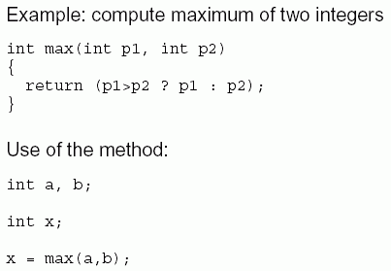

Example: compute the factorial of an integer
"factorial": n! = n * (n–1) * ... * 3 * 2 * 1.

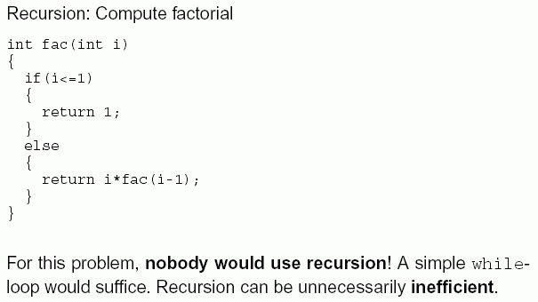

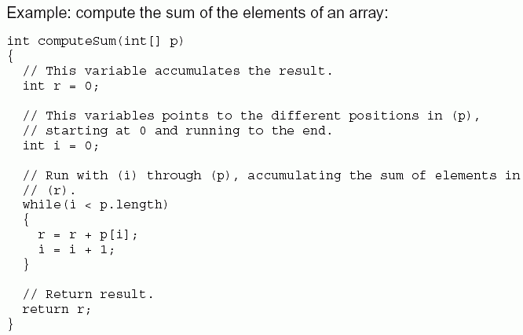

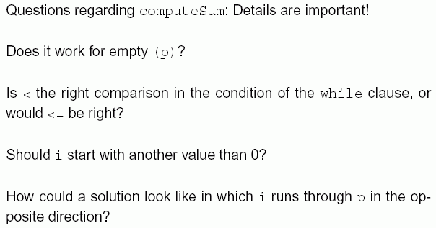

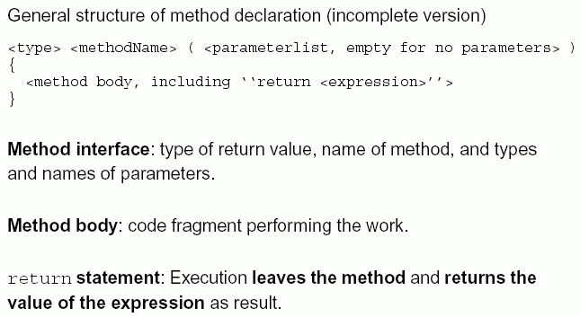

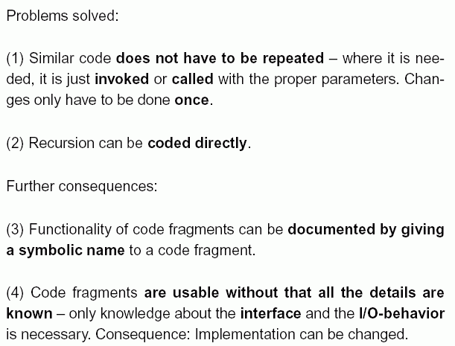

Method call:
e.g. x = max(a, b);
Effects:
- control flow jumps from the place where the method is called to the place where the method is defined
- the method is executed
- the control flow jumps back to the place where the method was called and the return value is assigned to x.

Control structures of Java

control structures:
language concepts designed to control the flow of operations
– typical for the von Neumann paradigm

particularly: branching of the programme; loops.

Variants of branching:

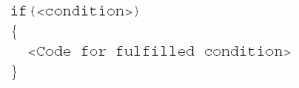

(if the condition is false, nothing happens)

if (<condition>)
{
<Code for fulfilled condition>
}
else
{
<Code for unfulfilled condition>
}

Nesting of if...else possible:

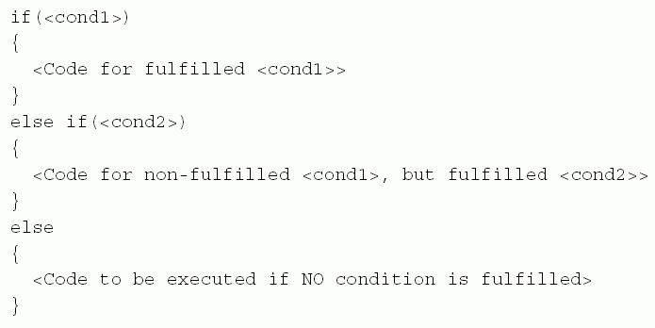

Example application: Finding the solutions of a quadratic equation ("pq-formula")

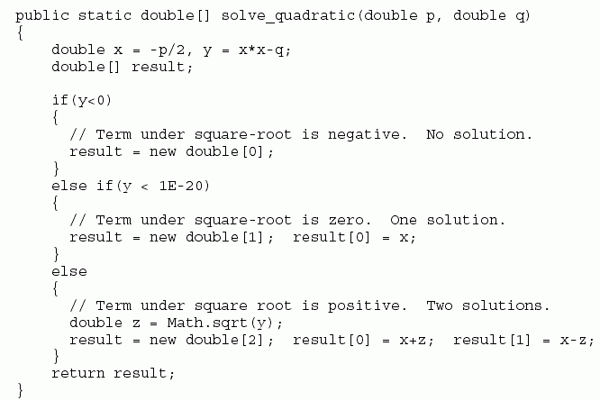

Alternative: switch construction
Branching not binary, but with several alternatives at the same level

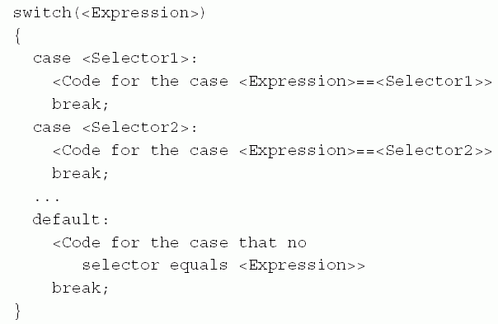

Example application:

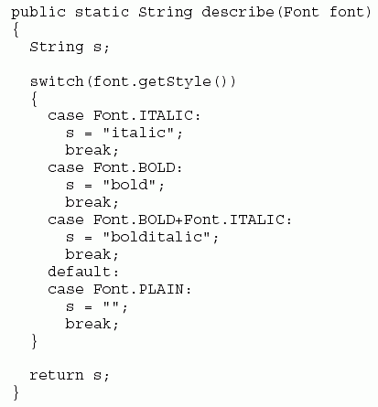
Special form of branching for error handling:
the try construction

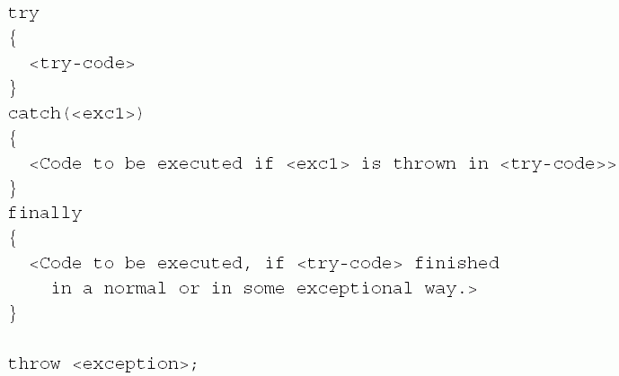

Example application:

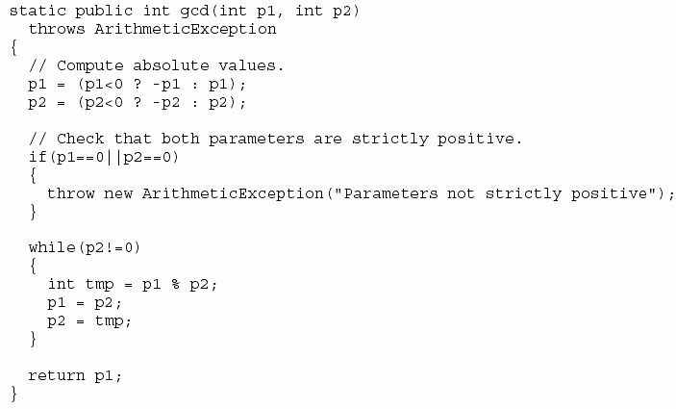

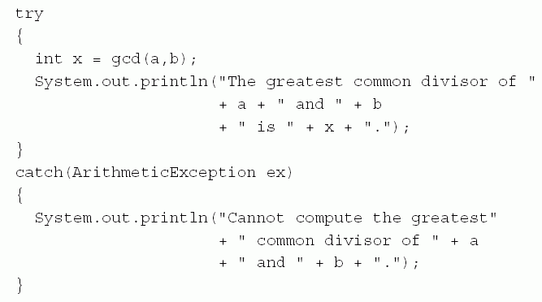

Loops:
we have already used the while loop.
Second variant: "do ... while"

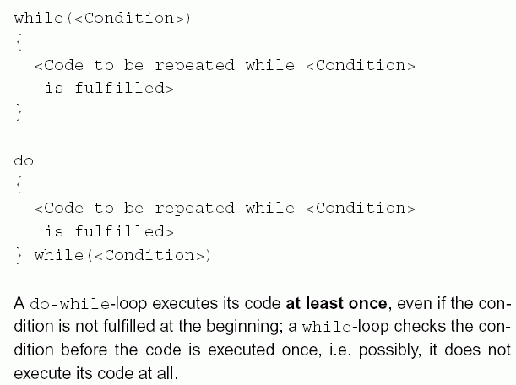

The for loop

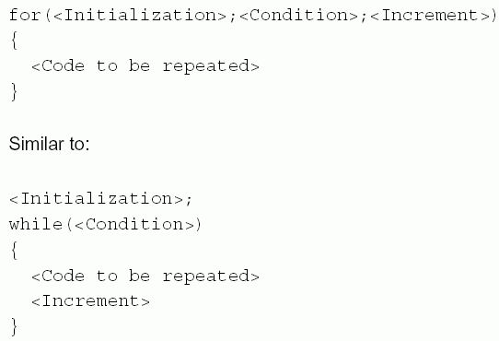

Application example:

