4a. Programming languages (continued)

Programming languages differ not only in their underlying paradigm, but also in many other aspects

- e.g., in the way how functions and operators are written

a function:

mathematically a mapping

f: a₁ a₂ a₃ a₄ → r ( = result)

in mathematics we write normally:

f(a₁, a₂, a₃, a₄) = r

Different numbers of arguments ("arity"):

f() 0-ary function (no argument)
f(a₁) unary function
f(a₁, a₂) binary function
f(a₁, a₂, a₃) ternary function
....

in this notation, first comes the function symbol
and then the list of arguments (enclosed in parentheses)

= "prefix notation"

Disadvantage: in case of nested functions, evaluation proceeds from right to left (contrary to usual direction of reading in everyday life)
g( f(x) ) : apply first f, then g
An operation like "addition" can also be seen as the application of a function "+"

in this case we write usually a₁ + a₂

= "infix notation"

The function symbol stands between the two operands

- in prefix notation it would be +(a₁, a₂)

Disadvantages of infix notation:
- only possible for 2 arguments
- danger of ambiguities: a1 + a2 * a3
must be resolved by priority rule

Both prefix and infix notation are used in many programming languages, e.g. C and Java

3rd possibility: "postfix notation"

used in the language PostScript for all functions (including addition, multiplication...)

- function and operator symbols stand always behind their operands
- if consequently applied, no parentheses necessary!

a₁f stands for f(a₁)
a₁a₂f stands for f(a₁, a₂) etc.

also a₁a₂ add for a₁ + a₂

xfg : apply first f, then g (order of evaluation from left to right)
example: what is the result of the PostScript expression
3 5 7 add 1 sub mul ?

3 12 1 sub mul

3 11 mul

33

In other languages, too, postfix notation is sometimes used
e.g. in Java and C: x++ means "increment x by 1"
"++" as an operator in postfix notation

5. Boolean algebra and propositional logic

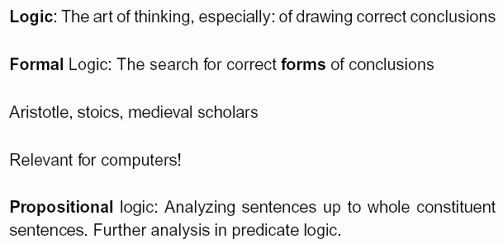

What is a "proposition" ?

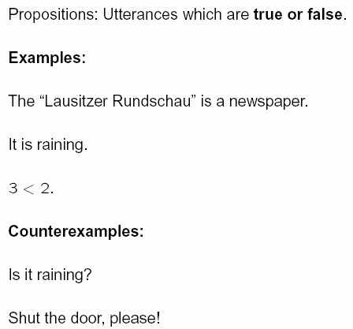

Truth values of propositions: true, abbreviated: T or t
false, abbr. F or f
Propositions can be combined using junctors

(operators controlling the truth of the combined proposition)

Examples:
The "Lausitzer Rundschau" is a newspaper and the Venus is a planet.
3 < 2 or 1+1=2 .

Symbolic notation for propositional junctors:

¬ "not" (Negation; has only one operand)

∧ "and" (Conjunction) – reminder: And ≈ Λ

∨ "or" (Disjunction) – reminder: latin "vel"

→ "implies" (Implication)

↔ "are equivalent" (Equivalence)

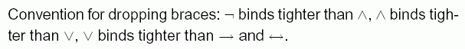

"Truth tables":
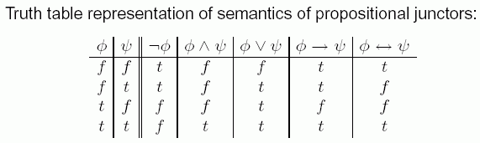
further junctors: NAND (not and) and NOR (not or)

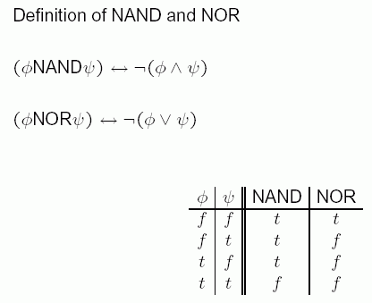

Boolean functions

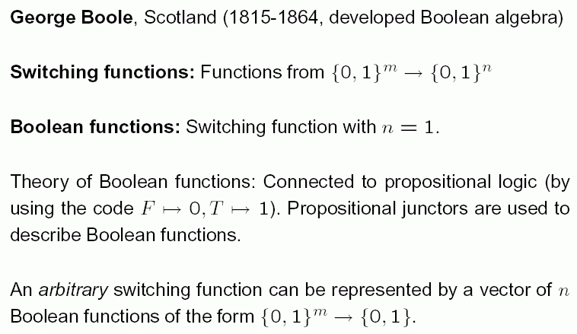

How many Boolean functions are there
with n arguments?

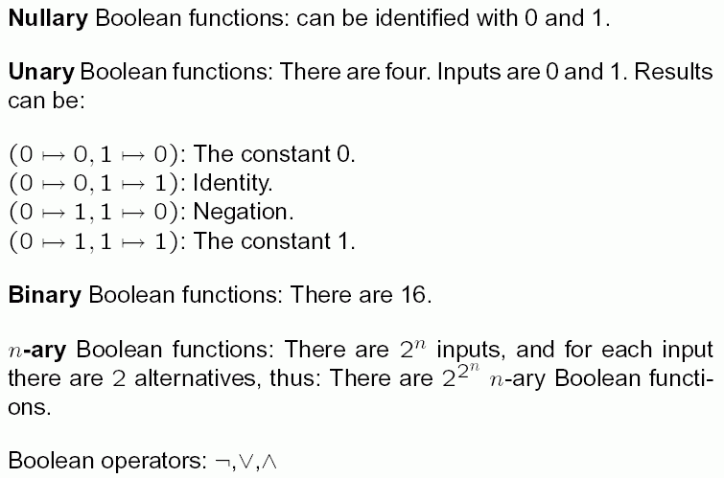

Binary Boolean functions:

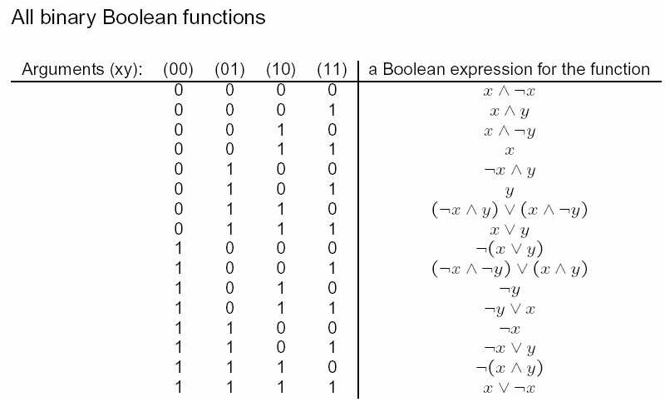
Each n-ary Boolean function can be built from binary Boolean functions.
Applications of Boolean functions:

- design of switching circuits from simple elements (e.g., NAND- or NOR-gates)
- combination of conditions which must be fulfilled in order to execute some parts of programmes (most programming languages provide Boolean data type and functions)
- part of network models, e.g., in molecular genetics
- Proofs of equivalence of logical expressions
- they are part of logic-based programming languages like PROLOG
- applications in "knowledge engineering"

How can knowledge be represented in computers?

- not only by simple listing of numbers
- not by text only (text must be read and interpreted by
humans, the computer cannot understand its meaning)

we need a representation of "knowledge items" (statements, facts...) which can be processed by the computer, i.e., sensefully transformed in a purely formal way (without interpretation by human beings)

A first step:

Propositional formulas

= basically: propositions where variables are allowed

We build propositional formulas recursively from:
- variables
- constants (T and F)
- junctors
- auxiliary symbols (parentheses)
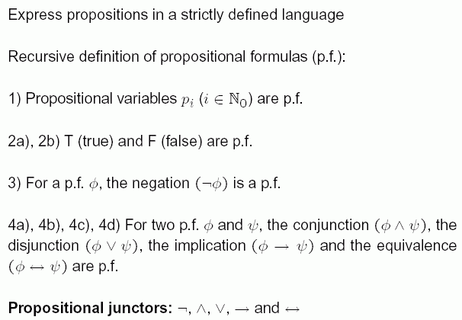

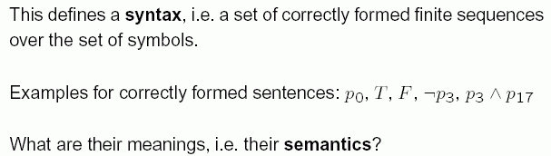

Assumption:
We can "know" if a proposition (without variables!) is true in a given situation.
(This means, we use only such "secure" propositions in our knowledge base – or we restrict the situations accordingly.)
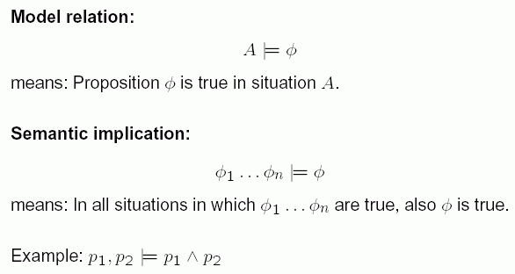

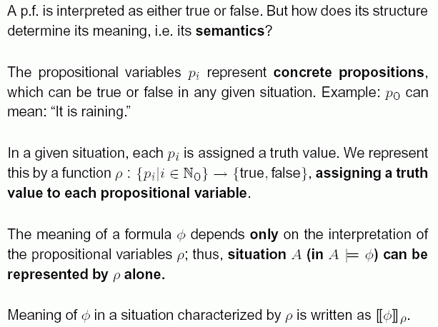

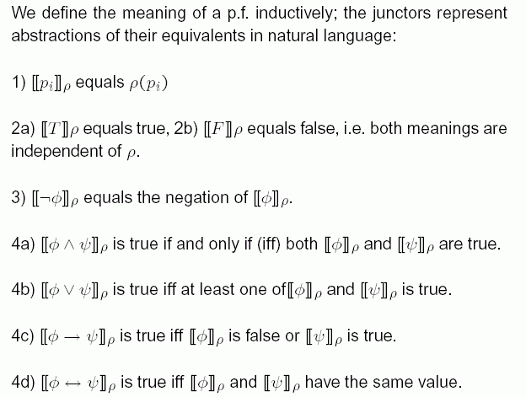

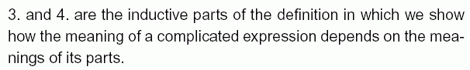

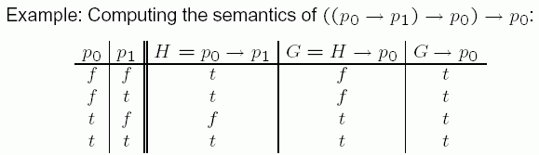

Properties of propositional formulas:

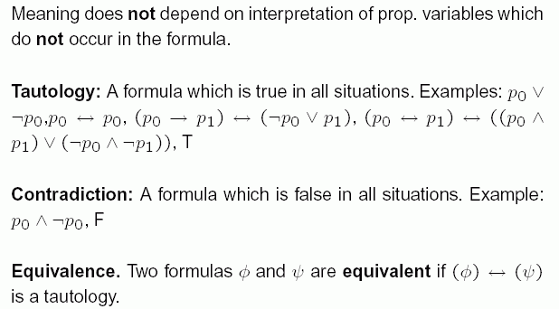

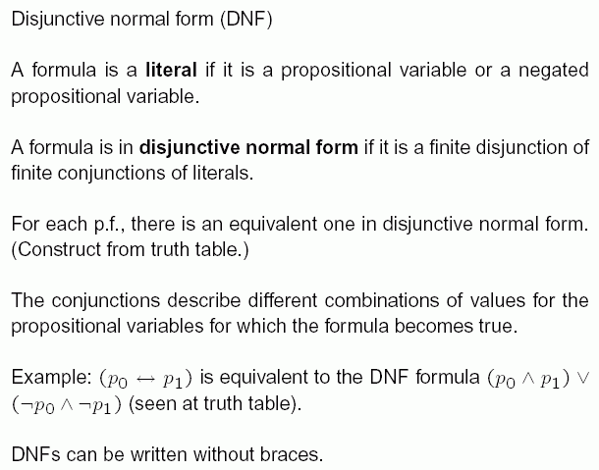

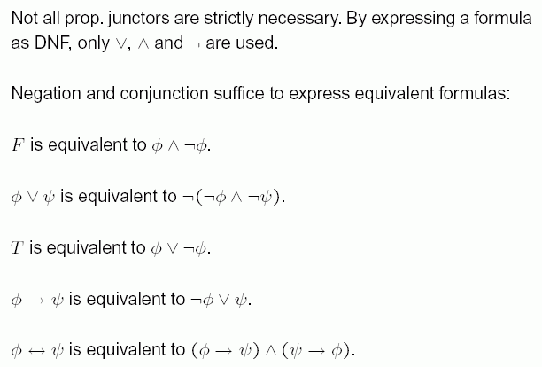

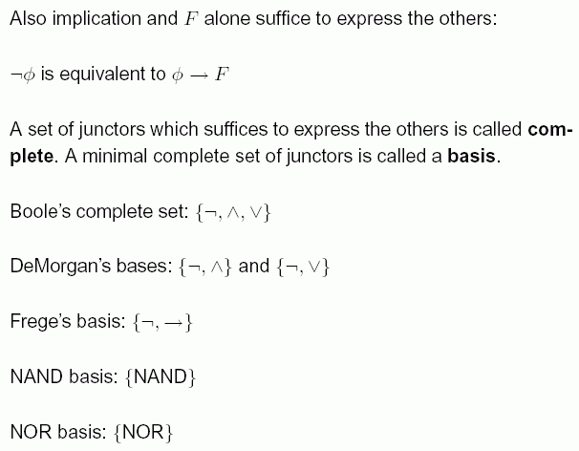

Some important equivalences of propositional logic / Boolean algebra:

The formulas in the right-hand column are all tautologies, i.e., they give always the value T (true)

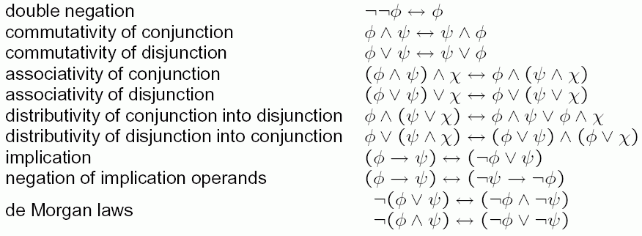

Propositional formulas alone are normally not sufficient to represent knowledge.
Even in mathematical statements, there are often additional informations connected with variables which cannot be expressed by a propositional formula:
E.g., "for all x, x+1>x"

Next complexity level of logic: Predicate logic
- not covered here in detail, only the basic notations:

