3a. Computer architecture and hardware (continued)

CPU components:

arithmetical-logical unit (ALU)

data registers:
data (inputs from system bus and output),
register address (input from control unit)

control unit (CU): instruction register, sequencer,
programme counter, status register (see below)

internal CPU bus for interconnection of the components

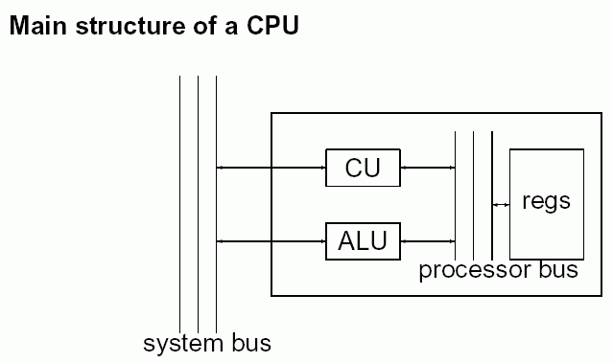

Components of the control unit (CU):

Instruction register (IR):
data (input from system bus), opcode (output to ALU), modifier (output to ALU), data address (output to system bus, to data registers)

Sequencer: controls sequence of operations for content of the instruction register

Programme counter (PC):
data (input from ALU, output to system bus), add2/add4 (inputs from instruction register)

Status register (SR):
flagsIn (input from ALU), flagsOut (output to ALU), load (input from instruction register)

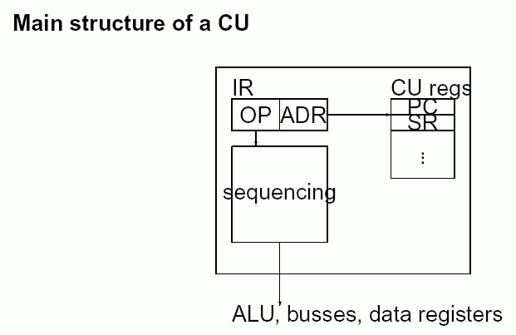

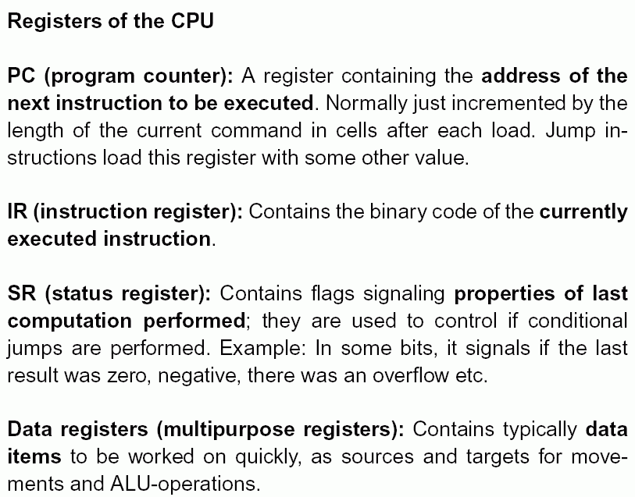

A typical 6-step ALU machine cycle:

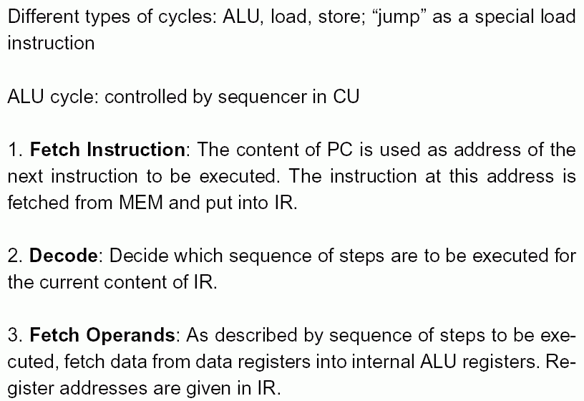
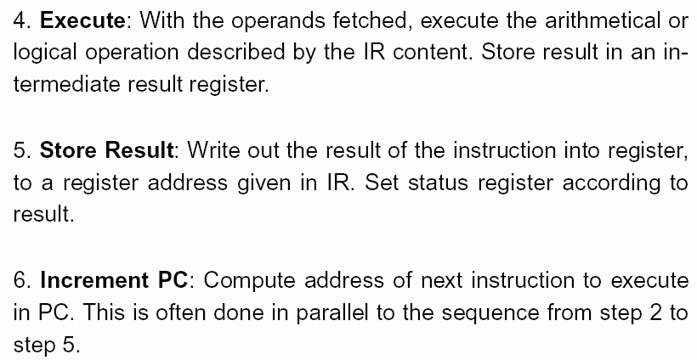

Assembler Code:

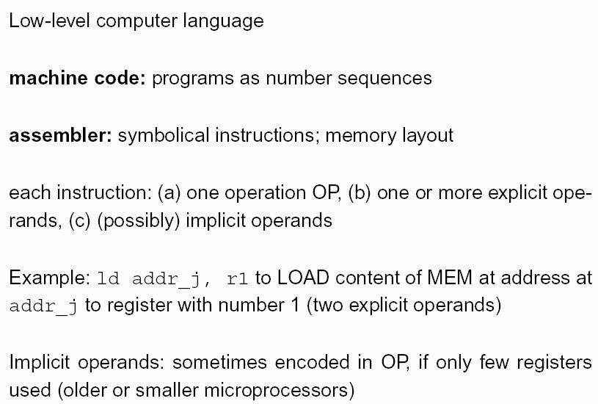

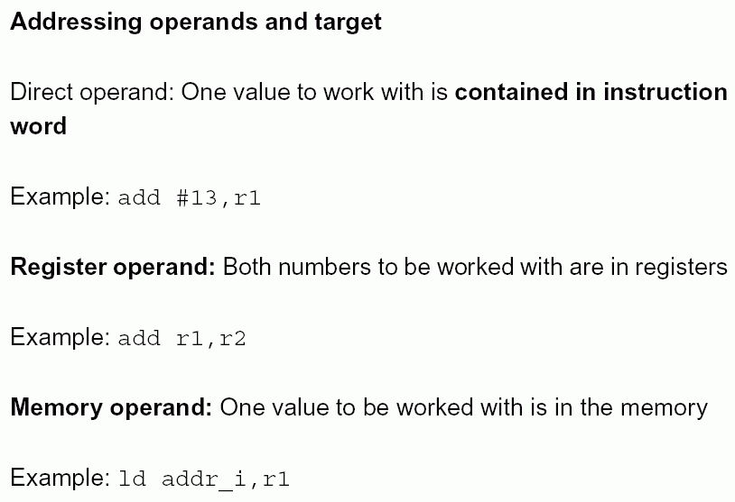

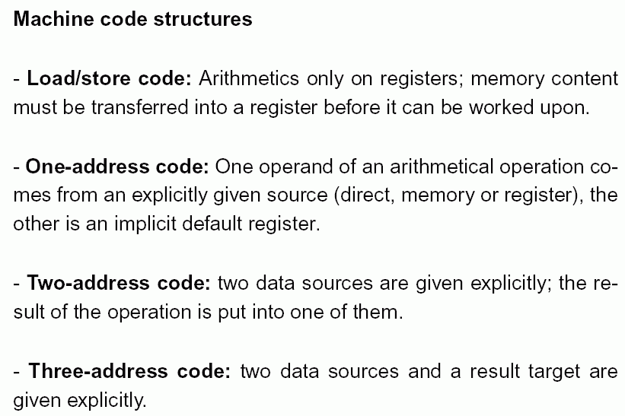

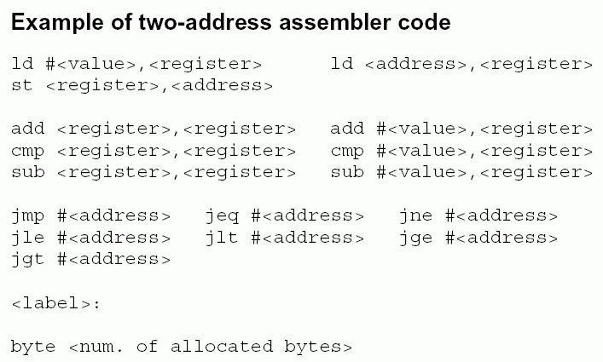

Different variants of the same programme:
(left column: programme in a high-level language – Java or C)

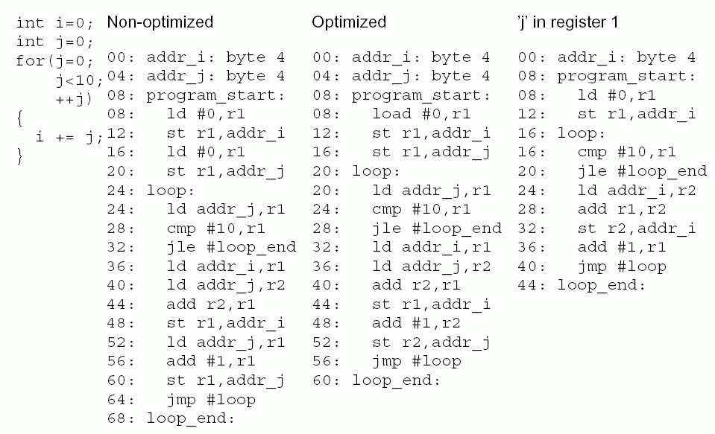

Physical realisation of the CPU and memory
(hardware):

Semiconductor (silicon) chips
highly integrated arrangements of electronic switches (transistors) and electronic storage elements on (mostly) 2-dimensional plates
produced with optical-chemical imprinting methods

A microprocessor:

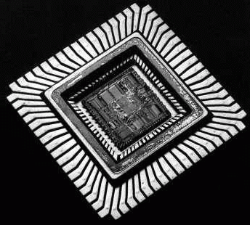

Alternative techniques:
- optical computing (using light instead of electricity)
- quantum computing (using quantum effects, especially
for parallelisation)
both are currently more of theoretical interest,
no mature technologies

other hardware components:

The periphery

(= all what is connected with a computer but the task of which is not primarily to compute)

Keyboard
normally resembling traditional typewriter keyboard, with additional number panel and function keys
– electrical switches below the buttons

Caution: placement and lettering of keys depends on country
Operating system of the computer must "know" the key scheme

Mouse
most important graphical input device
– mechanical mouse: ball with motion sensors
– optical mouse: tracking of motions using light emission
and sensing
Motion signals are interpreted by operating system and/or application programmes

Display

transforms electrical signals in non-permanent optical signals
traditionally solutions technically different from television
(but currently trend to converge: digital TV, multimedia programmes...)

2 main techniques:
- cathode ray tube (CRT)
- liquid crystal disply (LCD)

Cathode ray tube:
- Electron ray is emitted by a cathode
- direction controlled by magnetic fields
- hits substance on the inner side of the screen glass which emits light when stimulated by electrons

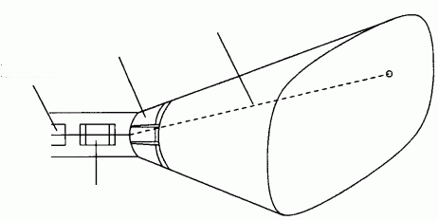
cathode
control of direction
electron ray
focusing unit

electron ray hits pixel only for short time
but: persistence of light emission for some time after stimulation (phosphorescence)

⇒ persistence determines the necessary refresh rate to ensure the impression of a flicker-free, standing image

picture repetition frequency (for refresh):
usually between 30 and 80 pictures per second

(if it is too small in relation to the persistence: Blurring when motion occurs, "ghost images")

Colour display:
Shadow mask colour CRT

3 separate cathodes
screen covered with triples of red, green and blue phosphor dots
mask with small holes in front of the phosphor dots ensures that each of the 3 rays hits only its appropriate colour dots
colour perception by additive composition of red, green and blue light
electron ray systems
(for red, green, blue)
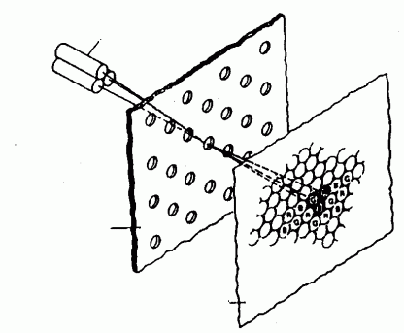
mask
glass with phosphor dots of different colour

(other arrangements of the dots exist, e.g. in lines instead of triangular – "inline displays")

Evaluation of the CRT technique:

(+) high resolution
(+) good colours, high luminance
(+) relatively cheap
(+) mature technique, low defect rate
(–) vacuum tubes are heavy and clumsy
(–) high power input (∼ 80 W)
(–) flickering
(–) geometrical distortions
(–) X-ray emission

Liquid Crystal Display (LCD):

liquid crystals (discovered 1888 by Reinitzer):
- organic molecules, oval or disk-like form
- axes tend to be orientated in parallel

Twisted nematic cells:
liquid crystals enclosed between two glass plates with polarising characteristics, caused by tiny ridges
rotated by 90° against each other

glass plates transmit only light oscillating in one specific direction (polarised light)

- Without tension, the LC molecules arrange in a way that causes a light beam to twist and to pass both glasses

- With tension (5 V), the molecules reorientate and the light passing the first glass is not twisted ⇒ it cannot pass the second glass
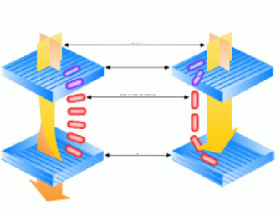

Each cell of the screen must be controlled separately
⇒
Thin Film Transistor (TFT) technology:
each cell has its own electronic switch (transistor) positioned in one corner of the pixel
production with photochemical techniques

Structure of an LCD:

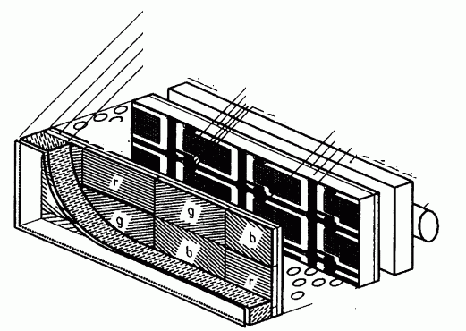
polariser
glass
electrode
RGB filters
transistors
with network of control connections
dispersing
glass
light source
liquid crystal
Evaluation of the LCD technique:

(+) low power input (25 W)
(+) low voltage
(+) no flickering
(+) good contrasts
(+) digital
(+) low weight, small
(+) appropriate for mobile machines
(–) cells work passively: extra light source necessary
(–) narrow view sector
(–) production relatively complicated

Further graphical output devices:

Plotters

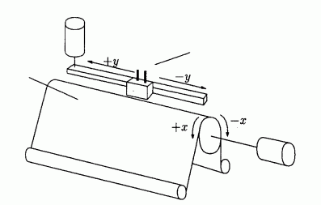
pens
rotating
cylinder
motor
motor
paper rolls

Printers:

- matrix printer (needles, mechanically printing, typewriter principle)

- inkjet printer (jets pressing ink on the paper)

- xerographic printers ("laser printers")
(same principle as in copy machines):
Original
rotating mirror
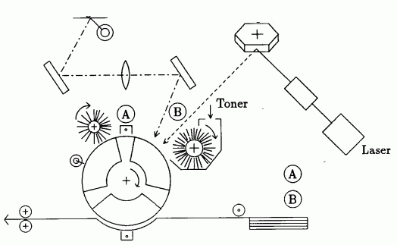
charging

exposition to light
Paper
fixation
cleaning
decharging

color printing realised by serial combination of several stations with differently coloured toners.

Realisation of gray values and colours with printers which can only print black and white (or only few colours):

Halftone technique

halftone matrices for 5 gray values using only black and white
4. Basic facts about operating systems and programming languages

Operating system (OS):
Basic software which manages all technical procedures necessary when using a computer, like
- starting the computer when it is switched on ("booting")
- allocating memory space
- reading and writing files
- organising files (e.g., in "directories")
- communicating with the periphery
- organizing input and output
- control of programme execution

Different philosophies of giving commands to the OS:

- typing the command in a command line

- clicking with the mouse on (virtual) buttons, menues, sliders, icons...: The command line is replaced by a GUI (Graphical User Interface), often with "desktop metaphor" (attempt to mimick a real office desktop – but it isn't really so!)

Important contemporary operating systems:

- Microsoft (MS) Windows (variants XP, 2000, NT, 98...)
- Unix (several variants exist, e.g. for Sun, IBM, SGI...)
- Linux (similar to Unix, free software)
- Mac-OS (Apple)
- MS-DOS (old predecessor of MS-Windows): pure command line system

Files:
sequential collections of data, stored on data carriers (harddisks, floppies, CD-ROM, DVD, tape...),
can be identified by file names.

Caution:
The sequential order of data in a file does generally not directly correspond to a physical order of the data on the carrier medium!
Data are often "physically fragmented"
(you can use defragmentation programmes to speed up access to files on your computer)

The data carrier must be formatted and initialised:
this induces a subdivision in so-called "cylinders" and "segments" (abstract notions!)
On each data carrier, there is an FAT = File Access Table – to find the files on the carrier

In nearly all operating systems, there is the possibility to organise files in hierarchical directories (or "folders").

Navigation in the tree of directories:
- in MS-DOS and Windows:
X:\directory\directory\... \filename = "path"
(X: is the name of the drive,
normally: A: floppy disk drive,
B: floppy disk drive,
C: hard disk drive,
D: hard disk drive,
E: CD-ROM drive or DVD drive)
- in Unix and Linux:
/directory/directory/... /directory
- there is only 1 root directory
- the separating character is "/" instead of "\"
Naming of files:

- in MS-DOS and Windows:
often the name structure name.extension
is used,
where "extension" is short (preferentially 3 letters)
– historical reasons (MS-DOS).
Attention: the extension is often not displayed
(this feature can be switched on or off).

Typical extensions:

.EXE executable programme
.COM (small) executable programme
.TXT text file
.DOC Word document (formatted text)
.GIF image file
.JPG image file
.PS PostScript file (printable)
.PDF document file for Acrobat Reader software
.HTM or .HTML web document
.JAVA Java code (programme source code)
.BAT batch file: command sequence for the OS

Special files: AUTOEXEC.BAT, CONFIG.SYS,
WIN.INI
- control booting behaviour and configuration
of the computer (known periphery, keyboard
language, mouse...)

- in Unix and Linux:
less restrictions to file names than in DOS
names beginning with a dot (.) designate "hidden" files
Examples: .login , .profile (control files like AUTO-
EXEC.BAT)
Files can have attributes:

- hidden
- write-protected
- Archive
- system file ...

Systematic access control flags under Unix and Linux:

r = read (you are allowed to read)
w = write
x = execute

each can be given for:

u = user
g = group
o = others

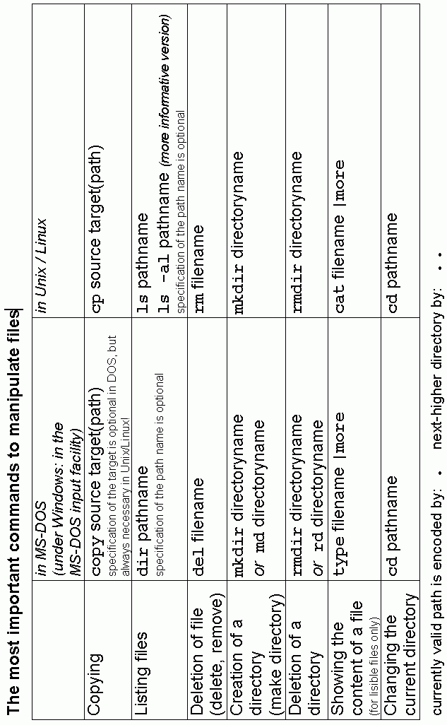
Up to now: 3 sorts of programming languages were introduced

- machine code
(machine-specific, directly executable,
sequences of bits, resp. half-bytes – hexadecimal code:
hard to read for humans)
- assembler languages
(translation of machine code in mnemonic abbreviations like
"add", "jmp"...; but still machine-specific and
of a technical nature)
- operating system commands
and several of them combined: "batch files"
→ OS translates them into machine code instructions
machine-independent, but specific for the OS
– only of limited power and flexibility

"High-level programming languages":

artificial languages
- designed for humans: lisible, easy to learn, intuitive
- also designed for computers: efficient to implement
- providing full power and flexibility

Programmes written in a high-level language must be translated into machine instructions

Two ways of implementation:

Interpreter
simulates a computer which understands the high-level language (i.e., the source code written in it)
→ enables interactive programming

source code → interpreter ↔ computer

Examples of languages: Smalltalk; simple versions of Basic

Compiler
translates the whole source code into machine code
→ this can enable an improvement of efficiency (optimisation) already during translation (compilation)

source code → compiler → target code → computer

Examples of languages: C, C++, Pascal, Fortran

In the case of larger programmes, often two steps are done:
- Compiler translates single modules (parts of the software)
- Linker merges these into an executable programme

Development tools for specific languages often contain
editor (for source code text) + compiler + linker + debugger + further tools.

Combination of both approaches (aim: platform independence, "write once – run everywhere"):

source code → compiler → intermediate code
(byte code)
indep. of processor and OS

intermediate code → interpreter ↔ computer
(e.g.
JVM = Java virtual machine)

Example language: Java.

To be distinguished:

- source code files (name extensions .java, .c, ...)

- objectcode files (compiled, but not yet linked modules)

- intermediate code files (.class)

- executable programmes (applications; name extensions .exe, .com or without extension)

- applets: executable programmes which cannot run alone but only from other applications, usually from web browsers (are not allowed to modify files on harddisk)

- control files for compiler or development tools (.prj, makefile)

"Evolution tree" of high-level programming languages:

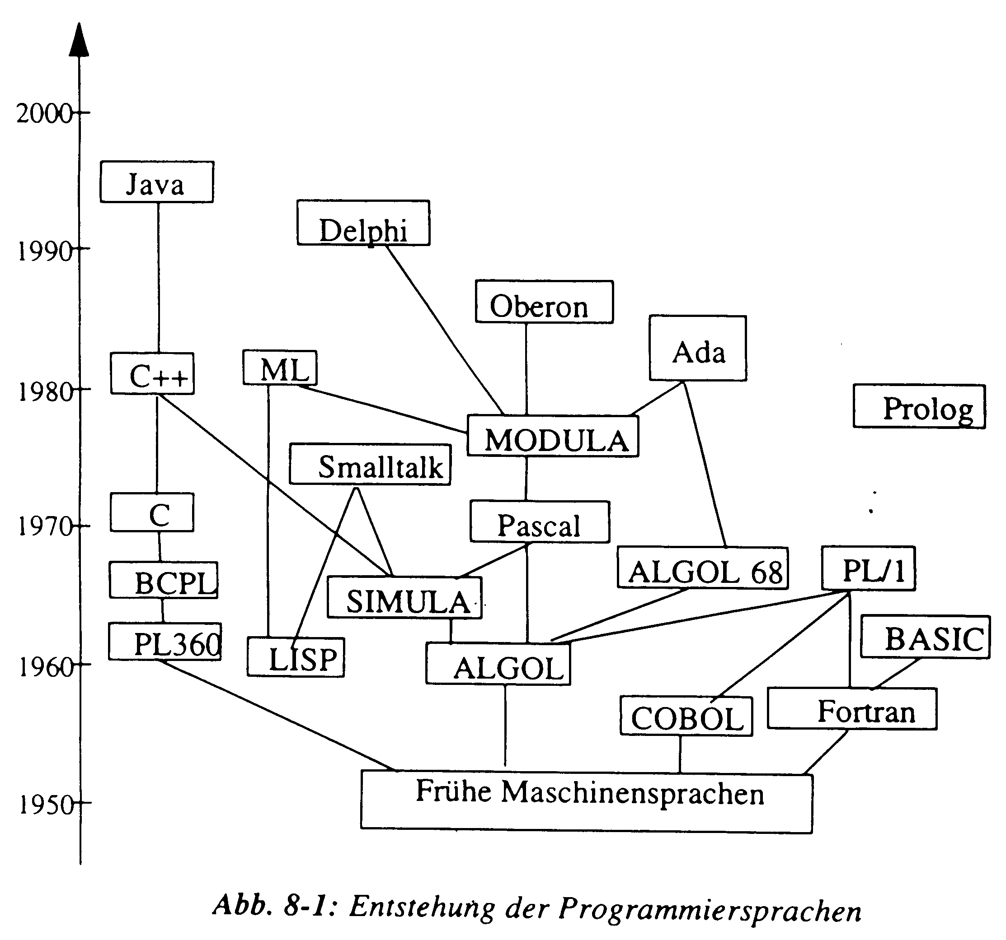

Development of programming languages
early machine languages
Very widespread programming languages:

FORTRAN (1955) ("Formula Translator")
particularly for numerical computations,
programme libraries

COBOL (1960) ("Common Business Oriented Language")
classical commercial applications

C, C++ (1971, 1992)

PASCAL (1971)

JAVA (1995)
internet applets

To be distinguished from "proper" programming languages are document description languages like, e.g.,
HTML, XML, PDF, RTF, TEX

Intermediate form: PostScript
(Printer language, but incorporates also the possibilities of a universal programming language)
How to order the many programming languages in a meaningful way?

"Paradigms of programming":
basic ideas, philosophies behind the language concepts,
patterns of comprehension of "programming"

1. Control flow paradigm (von Neumann paradigm)
is the basis of classical procedural programming
- also realised in assembler code
High-level languages: Fortran, Basic, Pascal, C.
Computer = machine for changing values of variables.
Programme = plan for the process of calculation with specification of commands and flow of control (e.g., loops).
Finding a programme: To find elementary single steps and to bring them into a flexible order.
Example (in C):
int i, n, z;
n = 10;
i = 1;
while (i < n)
{
z = i*i;
printf("%d\n", z);
i = i+1;
}
printf("Finished.\n");
2. Object-oriented paradigm
Typical programming languages: Simula, C++, Smalltalk, Delphi, Java
Computer = Environment for virtual objects
Programme = Listing of (object) classes, i.e., of general specifications of objects which can be (multiply) created and destroyed at runtime of the programme and which can communicate with each other.
Finding a programme: Specification of the classes (data and methods) which determine object structure and behaviour.
Example (in C++):
class matrix
{
float field[3][3];
public:
void initmatrix(float value);
void identitymatrix();
void showmatrix();
friend matrix sum(matrix a, matrix b);
};

3. Functional paradigm
(applicative programming, McCarthy paradigm)
Programming languages: Lisp, Lambda calculus, APL, FP systems
Computer = machine which forms generalisations of operations, i.e., which can define functionals (like construction of new notions in mathematics)
Programme = nested expression of applications of functions
Finding a programme: specification of functions which can solve the problem
Spezifikation von Funktionen, die das Problem lösen
Example (FP system according to Backus):
def innerprod = (/+) ° (a*) ° trans
defines the inner product of two vectors of arbitrary dimension
Note: no sequentialisation, no declarations of variables, very compact programmes are possible.

4. Rule-based paradigm (van Wijngaarden paradigm)
Programming languages:
PROLOG, rule-based AI languages, L-systems, Intran
Computer = transformation machine for states or structures
There is a current state (a current structure) which is transformed as long as this is possible.
Working process: process of search and application (of rules) – "matching" and "rewriting".
Programme = set of transformation rules.
Finding a programme: Specification of the rules.
Example (in Intran):
GCD OF M, N where
M=N -> M;
M>N -> GCD OF M-N, N;
M<N -> GCD OF M, N-M.

Real programmes often contain elements from different paradigms.
Examples:
- procedural (imperative) parts in Simula, C++ and Java
- declaration of variables in L-systems, etc.

Using a certain paradigm of programming does not yet determine the choice of the programming language!
Example: Object-oriented programming (OOP) is also possible in Fortran or C (but with high effort).
But: Using the "appropriate" programming language is helpful because it already offers the constructions needed for realising the paradigm – thus it is not necessary to define them again (e.g. classes in OOP).

