2a. Codes and number systems (continued)

How to get the binary representation of an integer:

special case of application of the inverse Horner scheme
⇒
repeated (integer) division by two.

Example:
What is the binary representation of 22 ?

22 div 2 = 11, rest 0
11 div 2 = 5 , rest 1
5 div 2 = 2 , rest 1
2 div 2 = 1 , rest 0
1 div 2 = 0 , rest 1

⇒ 22₁₀ = 10110₂

In case of fractions (numbers with decimal point):

- treat the fractional part separately
- apply repeated multiplication by 2 (with integer results and fractional rest) to it

Example:
What is the binary representation of 0.375 ?

0.375 * 2 → 0, rest 0.75
0.75 * 2 → 1, rest 0.5
0.5 * 2 → 1, rest 0

⇒ 0.375₁₀ = 0.011₂

⇒ 22.375₁₀ = 10110.011₂
Integer representation in finite cells ("words" with fixed length):

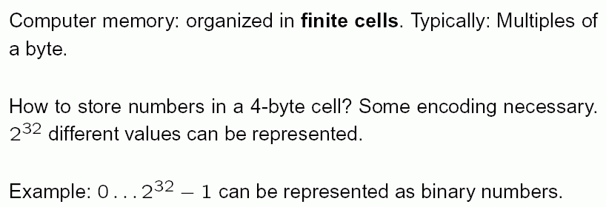

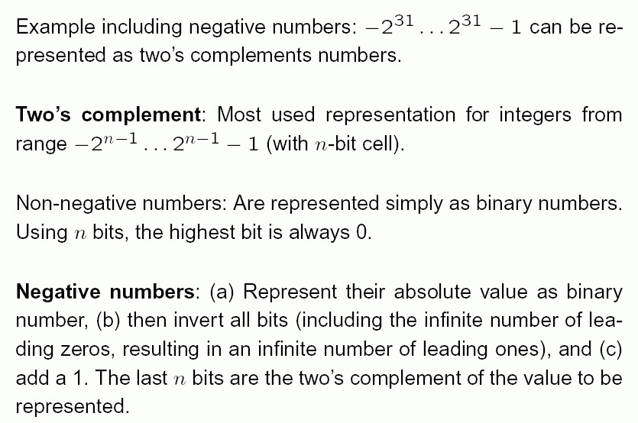

Example for the "Two's complement":

8-bit two's complement representation of –77

1. Represent +77 as a binary number: 1001101
2. Invert all bits, including the leading 0s: ...1110110010
3. Add 1: ...1110110011
4. Use only the lowest (= rightmost) 8 bits: 10110011
Notice:
For 16-bit cells, the result would be 1111111110110011.

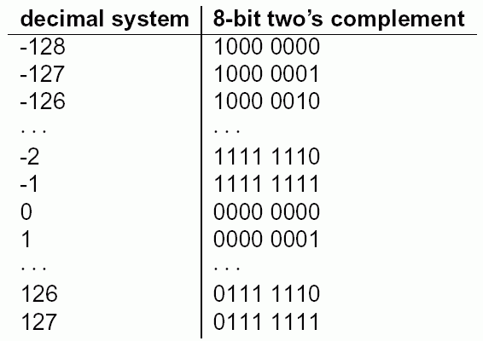

Properties of the two's complement:

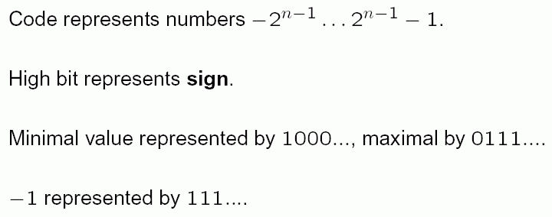

Floating-point representations

Built analogously to the "scientific representation"
of numbers in the form m * 10e

- but using the binary system:

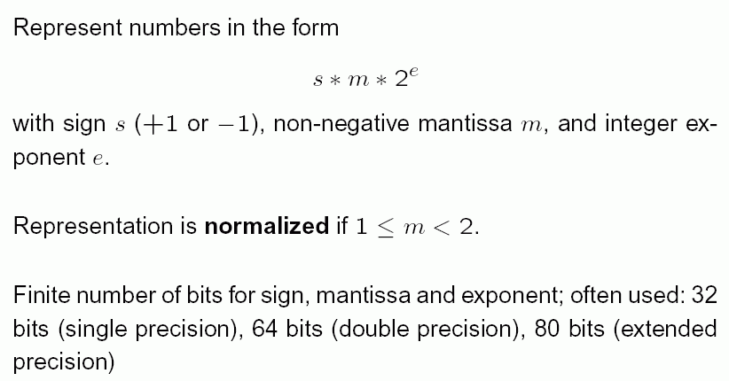

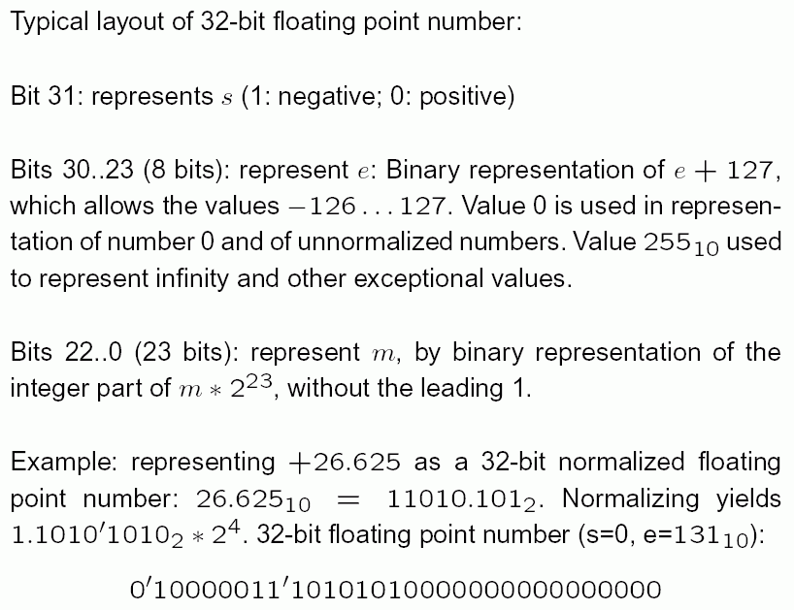
Digital representation of text

based on representation of letters
- depending on the alphabet: certain number of bits
necessary
- for 26 letters: at least 5 bits necessary
(2⁴ = 16 < 26, 2⁵ = 32 > 26)
- but also encoding of digits, special signs, upper- and
lower-case letters... desirable

traditional 7-bit code:
ASCII (= American Standard Code for Information Interchange)
ISO-646 norm
later extended to 8-bit code

examples: 00110000 = hex 30 = 48₁₀ = digit 0
00110001 = hex 31 = 49₁₀ = digit 1
...
00111010 = hex 3A = 58₁₀ = ':'
...
01000001 = hex 41 = 65₁₀ = 'A'
01000010 = hex 42 = 66₁₀ = 'B'
...
01100001 = hex 61 = 97₁₀ = 'a'
...

ASCII Table:

Non-printable characters | Printable characters
  Dez | Okt | Hex | Char | Code | Remark
  0 | 000 | 0x00 | Ctrl-@ | NUL | Null prompt
  1 | 001 | 0x01 | Ctrl-A | SOH | Start of heading
  2 | 002 | 0x02 | Ctrl-B | STX | Start of text
  3 | 003 | 0x03 | Ctrl-C | ETX | End of Text
  4 | 004 | 0x04 | Ctrl-D | EOT | End of transmission
  5 | 005 | 0x05 | Ctrl-E | ENQ | Enquiry
  6 | 006 | 0x06 | Ctrl-F | ACK | Acknowledge
  7 | 007 | 0x07 | Ctrl-G | BEL | Bell
  8 | 010 | 0x08 | Ctrl-H | BS | Backspace
  9 | 011 | 0x09 | Ctrl-I | HT | Horizontal tab
  10 | 012 | 0x0A | Ctrl-J | LF | Line feed
  11 | 013 | 0x0B | Ctrl-K | VT | Vertical tab
  12 | 014 | 0x0C | Ctrl-L | FF | Form feed
   |  |  |  | NP | New page
  13 | 015 | 0x0D | Ctrl-M | CR | Carriage return
  14 | 016 | 0x0E | Ctrl-N | SO | Shift out
  15 | 017 | 0x0F | Ctrl-O | SI | Shift in
  16 | 020 | 0x10 | Ctrl-P | DLE | Data link escape
  17 | 021 | 0x11 | Ctrl-Q | DC1 | X-ON
  18 | 022 | 0x12 | Ctrl-R | DC2
  19 | 023 | 0x13 | Ctrl-S | DC3 | X-Off
  20 | 024 | 0x14 | Ctrl-T | DC4
  21 | 025 | 0x15 | Ctrl-U | NAK | No achnowledge
  22 | 026 | 0x16 | Ctrl-V | SYN | Synchronous idle
  23 | 027 | 0x17 | Ctrl-W | ETB | End transmission blocks
  24 | 030 | 0x18 | Ctrl-X | CAN | Cancel
  25 | 031 | 0x19 | Ctrl-Y | EM | End of medium
  26 | 032 | 0x1A | Ctrl-Z | SUB | Substitute
  27 | 033 | 0x1B | Ctrl-[ | ESC | Escape
  28 | 034 | 0x1C | Ctrl-\ | FS | File separator
  29 | 035 | 0x1D | Ctrl-] | GS | Group separator
  30 | 036 | 0x1E | Ctrl-^ | RS | Record separator
  31 | 027 | 0x1F | Ctrl-_ | US | Unit separator
  127 | 0177 | 0x7F |  | DEL | Delete or rubout
  Dez | Okt | Hex | Char | Remark
  32 | 040 | 0x20 |  | blank
  33 | 041 | 0x21 | ! | exclamation mark
  34 | 042 | 0x22 | " | quotation mark
  35 | 043 | 0x23 | #
  36 | 044 | 0x24 | $ | Dollar character
  37 | 045 | 0x25 | %
  38 | 046 | 0x26 | &
  39 | 047 | 0x27 | ' | apostroph
  40 | 050 | 0x28 | (
  41 | 051 | 0x29 | )
  42 | 052 | 0x2A | * | asterisk
  43 | 053 | 0x2B | + | plus sign
  44 | 054 | 0x2C | , | comma
  45 | 055 | 0x2D | - | minus sign
  46 | 056 | 0x2E | . | dot
  47 | 057 | 0x2F | / | slash
  48 | 060 | 0x30 | 0
  49 | 061 | 0x31 | 1
  50 | 062 | 0x32 | 2
  51 | 063 | 0x33 | 3
  52 | 064 | 0x34 | 4
  53 | 065 | 0x35 | 5
  54 | 066 | 0x36 | 6
  55 | 067 | 0x37 | 7
  56 | 070 | 0x38 | 8
  57 | 071 | 0x39 | 9
  58 | 072 | 0x3A | : | colon
  59 | 073 | 0x3B | ; | semicolon
  60 | 074 | 0x3C | < | less than
  61 | 075 | 0x3D | = | euqality character
  62 | 076 | 0x3E | > | greater than
  63 | 077 | 0x3F | ? | interrogation mark
  64 | 0100 | 0x40 | @ | at
  65 | 0101 | 0x41 | A
  66 | 0102 | 0x42 | B
  67 | 0103 | 0x43 | C
  68 | 0104 | 0x44 | D
  69 | 0105 | 0x45 | E
  70 | 0106 | 0x46 | F
  71 | 0107 | 0x47 | G
  72 | 0110 | 0x48 | H
  73 | 0111 | 0x49 | I
  74 | 0112 | 0x4A | J
  75 | 0113 | 0x4B | K
  76 | 0114 | 0x4C | L
  77 | 0115 | 0x4D | M
  78 | 0116 | 0x4E | N
  79 | 0117 | 0x4F | O
  80 | 0120 | 0x50 | P
  81 | 0121 | 0x51 | Q
  82 | 0122 | 0x52 | R
  83 | 0123 | 0x53 | S
  84 | 0124 | 0x54 | T
  85 | 0125 | 0x55 | U
  86 | 0126 | 0x56 | V
  87 | 0127 | 0x57 | W
  88 | 0130 | 0x58 | X
  89 | 0131 | 0x59 | Y
  90 | 0132 | 0x5A | Z
  91 | 0133 | 0x5B | [
  92 | 0134 | 0x5C | \ | backslash
  93 | 0135 | 0x5D | ]
  94 | 0136 | 0x5E | ^ | caret
  95 | 0137 | 0x5F | _ | low line
  96 | 0140 | 0x60 | ` | back quote
  97 | 0141 | 0x61 | a
  98 | 0142 | 0x62 | b
  99 | 0143 | 0x63 | c
  100 | 0144 | 0x64 | d
  101 | 0145 | 0x65 | e
  102 | 0146 | 0x66 | f
  103 | 0147 | 0x67 | g
  104 | 0150 | 0x68 | h
  105 | 0151 | 0x69 | i
  106 | 0152 | 0x6A | j
  107 | 0153 | 0x6B | k
  108 | 0154 | 0x6C | l
  109 | 0155 | 0x6D | m
  110 | 0156 | 0x6E | n
  111 | 0157 | 0x6F | o
  112 | 0160 | 0x70 | p
  113 | 0161 | 0x71 | q
  114 | 0162 | 0x72 | r
  115 | 0163 | 0x73 | s
  116 | 0164 | 0x74 | t
  117 | 0165 | 0x75 | u
  118 | 0166 | 0x76 | v
  119 | 0167 | 0x77 | w
  120 | 0170 | 0x78 | x
  121 | 0171 | 0x79 | y
  122 | 0172 | 0x7A | z
  123 | 0173 | 0x7B | {
  124 | 0174 | 0x7C | |
  125 | 0175 | 0x7D | }
  126 | 0176 | 0x7E | ~

ASCII not sufficient for alphabets of the non-Angloamerican world (not even for European alphabets with ä, ö, ü, ß, é, ø, ñ, å...)

Unicode:
2 byte (= 16 bit) code for multilingual text processing
- can represent 65536 characters

amongst them: 27786 Chinese-Japanese-Korean
characters
11172 Hangul characters (Korean)
ancient Nordic runes
Tibetan characters
Cherokee characters ...

complete list see http://www.unicode.org/charts/

Unicode "Escape sequence" (to utilise it in the programming language Java):
e.g., \u0041 = 'A' (0041 = hexadecimal representation)

Some characters occur more frequently in texts than others:
better use variable-length code

UTF-8: Universal Transformation Format
Characters encoded with variable number of bytes
⇒ for texts with many ASCII characters (like on many web pages) shorter as Unicode

Strings (or words): sequences of characters
encoded by sequences of the corresponding code words

Digital representation of pictures:

Gray levels: encode each gray level by a number from a fixed interval (e.g. 0, 1, ..., 255: 8-bit representation –
0 = black, 255 = white)

Colours:
several colour models possible
the most frequently used one:

RGB model
(red / green / blue: primary colours for additive colour composition)
Each colour from a certain range ("gamut") can be mixed from these primary colours

examples with 8-bit intensities:

black (0, 0, 0)
white (255, 255, 255)
medium gray (127, 127, 127)
red (255, 0, 0)
green (0, 255, 0)
blue (0, 0, 255)
light blue (127, 127, 255)
yellow (255, 255, 0)

Pictures:
typically represented as raster images –
rectangular array (matrix) of pixels, each pixel represented by its 3 colour values.

Representation of text documents (book pages, web pages...):

Level of representation is important.

(1) Is there text on the page? – One bit.

(2) What is the text on the page? –
Representation of letter sequence (e.g., string of
ASCII characters).

(3) What is the exact layout of the text on the page? –
"formatted text"
- use special characters for formatting, or
- represent the page by a rasterized black-and-white
image.

Text documents with graphical elements:

- represent all as a single raster image, or

- use combined representation: several data files,
one for the text, the other for the pictorial parts
→ HTML web pages are built like this

file <name>.html or <name>.htm contains text,
layout information and links to other pages
files <name>.gif or <name>.jpg or <name>.png
contain images

Messages and redundancy

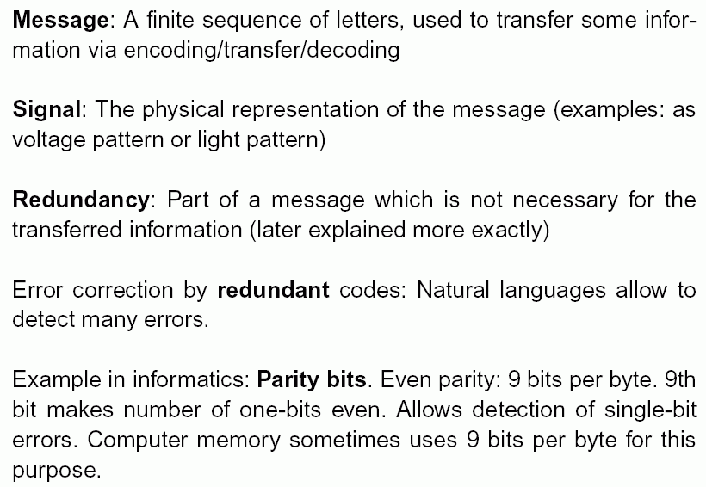
Other example: ISBN code (International Standard Book Number) –
last character is a parity character

Entropy and quantification of information

Shannon's information theory:
Information as a measurable, statistical property of signals

How can we measure information and redundancy of characters in a message?

Assumption: N-character alphabet { x₁, x₂, ..., x_{N} }

Number of bits per character:
H₀ = log₂ N

( log₂ N = (log N)/(log 2) )
Information content of a single character x_{i} : ${\text{log}}_{2}\frac{1}{p(x_{i})}$

Entropy = average value of information content
of all characters
= H = $\sum_{k=1}^{N}{p(x_{k})∗{\text{log}}_{2}\frac{1}{p(x_{k})}}$

Binary encoding needs at least, on average, H bits per character.

Redundancy: R = H₀ – H.

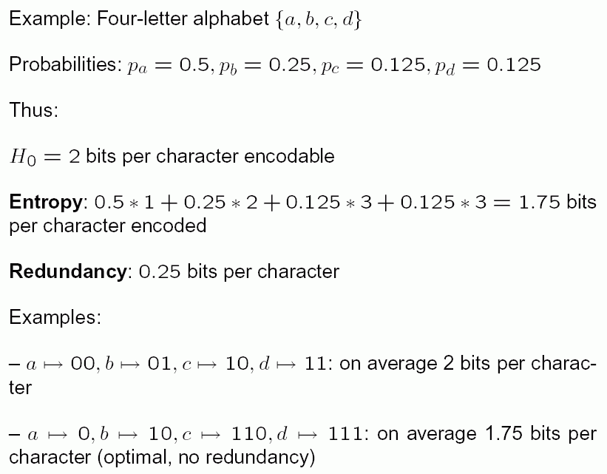

3. Computer architecture

Principal design of computers

Standard scheme, realised in most contemporary computers (with small modifications):
"von Neumann architecture"

Seven principles of the von Neumann architecture:

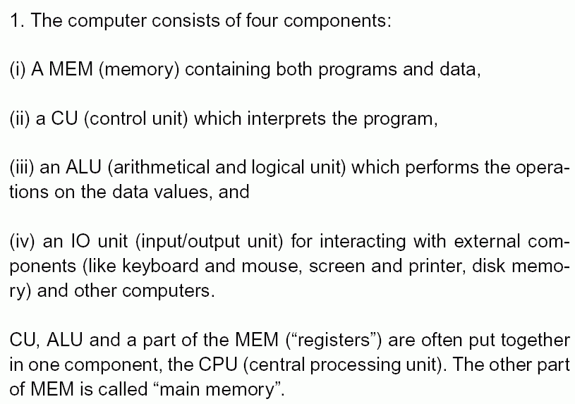

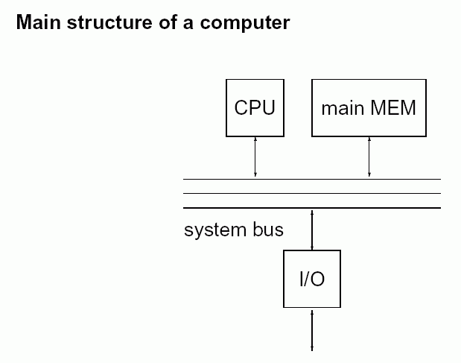
2. The structure of the computer is largely independent
of the programme. ("General purpose computer")

3. Main memory locations are used for both programme
and data; they can both be read and written by the
machine.

4. The main memory is split into cells of the same size.
Each of these cells can be addressed by its number.

5. A programme consists of a number of separated
instructions, encoded as cell contents of the main
memory. They are mostly executed in the order in
which they occur in the main memory.

6. The order of execution of instructions can be changed
by conditional or unconditional jumps to another
programme address.

7. Binary codes are used to represent numbers and
programme instructions.

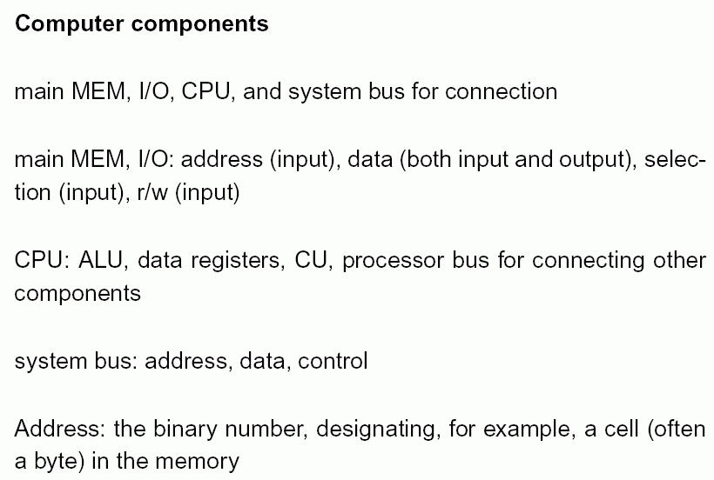
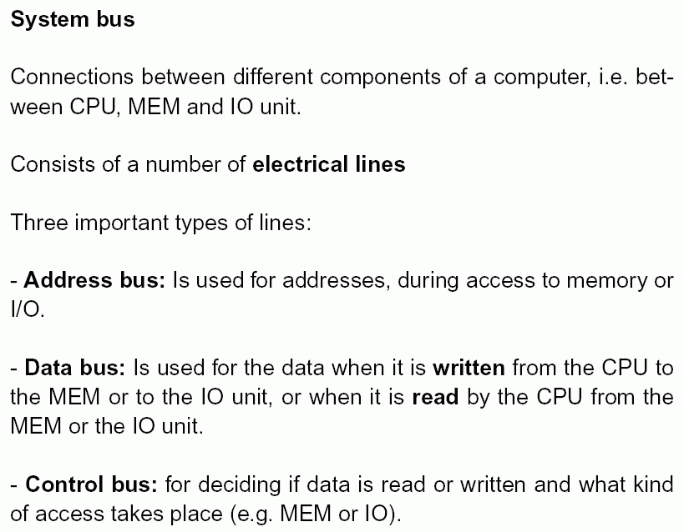

Example of an interface of 8 MB byte-organised MEM:

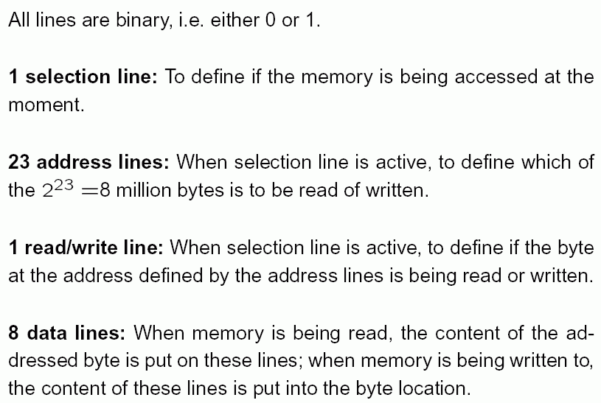
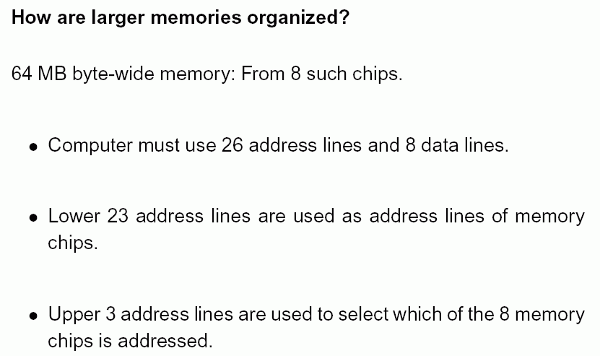

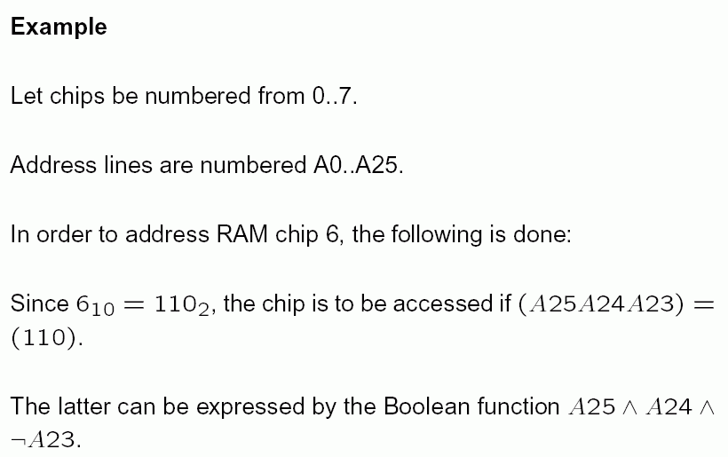
this means "A25 and A24 and not A23".

Boolean: having only a truth value (true or false) as result.

The Boolean function is built with logic chips. Its output is used for the selection line of the RAM.

