Computer Science

A series of lectures for students of Environment and Resource Management

Prof. Dr. Winfried KURTH
Chair for Practical Computer Science /
Graphics Systems, BTU Cottbus

Office: Ewald-Haase-Str. 12/13, room 116
Phone (0355) 69-3816
e-mail wk@informatik.tu-cottbus.de

http://www-gs.informatik.tu-cottbus.de/~wwwgs/

Winter term 2004/2005

Lectures:

Tuesday, 7:30–9:00am, room SR3

Script to be found in the WWW under the address

http://www-gs.informatik.tu-cottbus.de/~wwwgs/cs1_lect.htm

Exercises:

Friday, 7:30–9:00am, room EH/213 (Ewald-Haase-Str.);
alternatively: Computer pool in EHS
Content of exercise units:
- Basic introduction to computer usage (first 2 weeks)
- Discussion of home work
- Repetition of key parts of the lectures
- Written test examination in December
Grading:

Written examination at end of semester term

2nd try: Beginning of April

next written examination after this: not earlier than February 2006

⇒

Recommendation:

Take continuously part in the exercises and prepare yourself for the examination already during the semester term – then it will be easy to have success already in February, and if not, you have the second chance already in April!

Schedule:

Lectures "Computer Science"

Prof. Dr. W. Kurth

Winter term 2004/2005, Tuesday, 7:30-9:00am, room SR3

19. 10. | Introduction; information, codes, number systems
26. 10. | Representation of information; computer architecture
2. 11. | Hardware; operating systems, programming paradigms
12. 11. | Programming languages, operator notations;  propositional logic and Boolean algebra
16. 11. | From problem to programme; simple Java programmes (1)
23. 11. | Simple Java programmes (2)
30. 11. | Time complexity of algorithms
7. 12. | Basic algorithmic strategies and examples (1)
14. 12. | Basic algorithmic strategies and examples (2);  image processing
4. 1. 2005 | Working with databases (1)
11. 1. | Working with databases (2); Geographical Information Systems; the World-Wide Web
18. 1. | Automata and languages, grammars
25. 1. | Cellular automata and L-systems
1. 2. | Foundations of computer graphics, Virtual Reality, VRML
8. 2. | Software engineering; ethical aspects and Open Source
 | Written examination

1. Introduction

Fundamental notions;
historical and systematical overview

What is "Computer Science" / "Informatics" ?

"Computer Science" – science about a tool?
better names would be: "science of computing"
or "data processing science"
(focuses on activity instead of tool)

"Informatics": continental-European for "computer science"
- French: "Informatique" (since 1960s)
- German: "Informatik"

Definition: "Science of the systematical processing of information, especially the automatic processing by use of digital computers".

Latin "informare":
to give structure to something; to educate; to picture

Information:
- independent fundamental entity of the world besides matter and energy
- depends on previous knowledge of the receiver of the information
- various approaches to quantify it
- we can consider information simply as "interpreted data".

Data: represented information
(e.g. text in a book, magnetic patterns on a harddisk, ...)
But:
Hermeneutics – "the art of interpretation" – is not part of informatics, despite its name. Social and cultural aspects of information are largely ignored.

"Computer": comes from "to compute" = "to calculate".

"Algorithm":
The word comes from the Persian textbook writer Abu Ja'far Mohammed ibn Mûsâ al-Khowârizmî (= "father of Ja'far Mohammed, son of Moses, coming from Khowârizm" – a town in Usbekistan, today called Khiva.)

Al-Khowârizmî lived in Bhagdad, in the "House of Wisdom"
wrote book about calculation:
"Kitab al jabr w'al-muqabala" (= "rules of reconstitution and reduction")
– here the word "algebra" comes from!

Modern meaning of "algorithm":
Finite set of rules which specify a sequence of operations in order to solve a certain problem, with the following properties:

1. Termination: An algorithm must come to an end after a finite number of steps.
2. Definitness: Each step must be defined precisely.
3. Input: An algorithm can need input values (e.g. numbers).
4. Output: An algorithm must give one or more output values.
5. Feasibility: An algorithm must be feasible; e.g., no intermediate step must depend on the solution of some still unsolved mathematical problem.
(after Knuth 1973)
"Programme" (in American English: "program"):

Version of an algorithm which can be read, interpreted and carried out by a computer.

Programming languages were designed to write precise programmes (more precise than possible in our natural language!) suitable for computers.

History of computer science:

Place-valued decimal number system:
Helps to perform complicated arithmetical operations by simple steps. Example: Multiplication of large numbers.
Decimal number system came from India via the Arab world to Europe:

Leonardo of Pisa, called Fibonacci (1170–1250)
- was educated in North Africa where his father held a diplomatic position
- recognised the enormous advantages of the decimal system
- Book Liber abaci (1202): introduced Indian-Arabic number system to Italy

Germany:
Adam Ries(e), 1492–1559
- popularised the Indian-Arabic numbers in Germany
- Book "Rechnung auff der linihen vnd federn" (1522)

Since the 17th century in Europe: Machines which should help with computations.

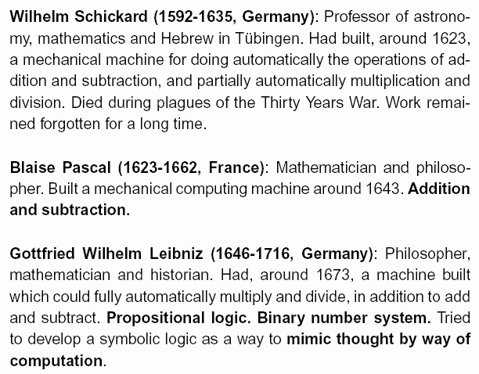

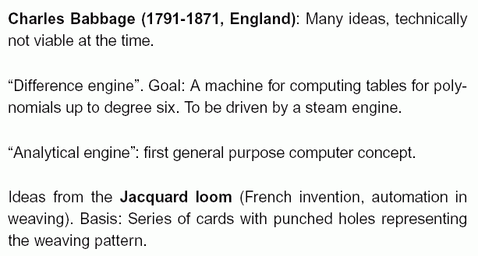

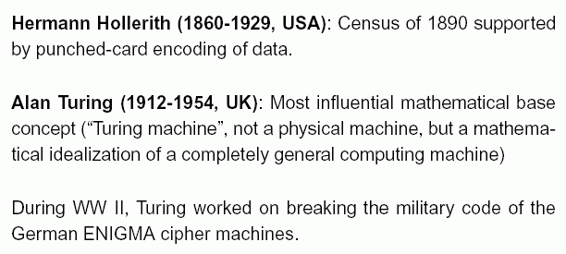

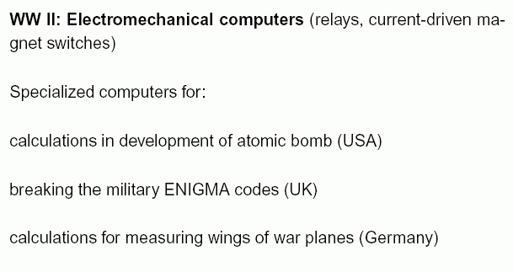

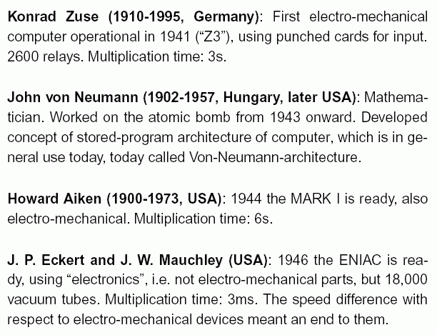
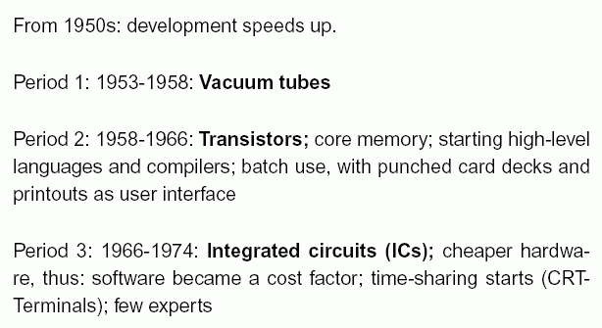

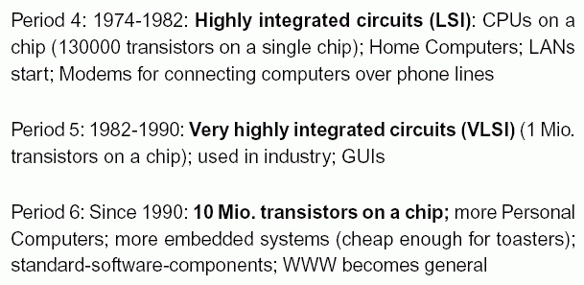
(Rust 2003)

Another history: that of programming

Early phases of computer history: Hardware (= the machines) was in focus (reason for the name "computer science")
Later: Software (= programmes) increasingly important, increasingly expensive in comparison to hardware.

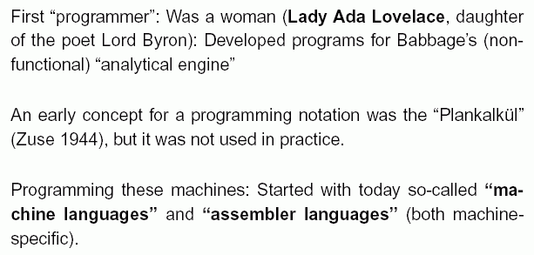

Later: so-called "high-level languages"
- more abstraction
- better readability for humans
- trying to integrate traditional mathematical notations
- platform-independent (not specific to certain machine)

FORTRAN (1954), COBOL (1958), LISP (1960),
Pascal (1971), C (1971), C++ (extension of C, 1992), Java (1995) ...

(see Chapter 4, later)

Subject areas of computer science

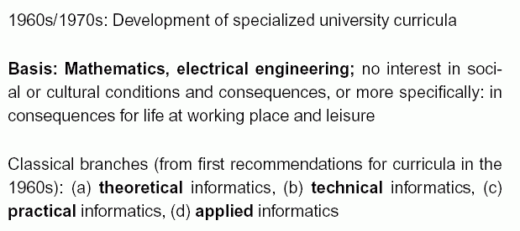
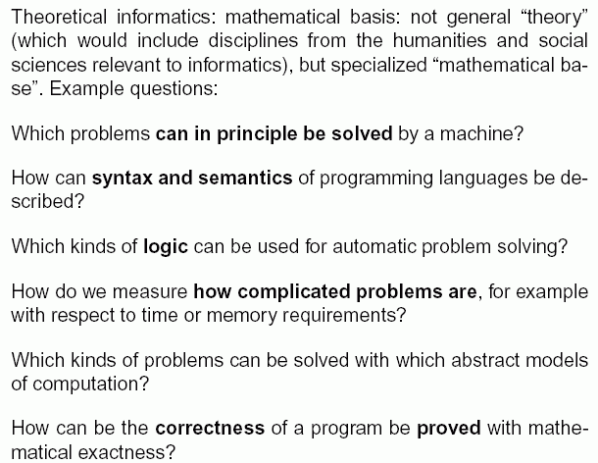

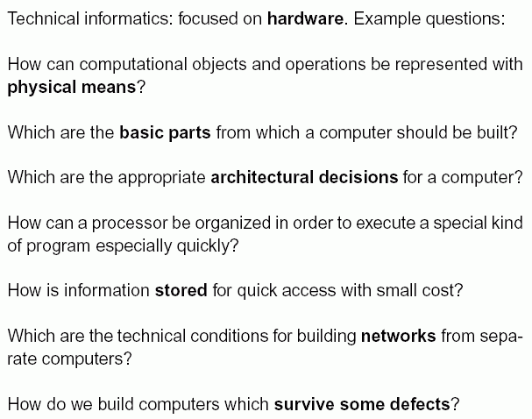

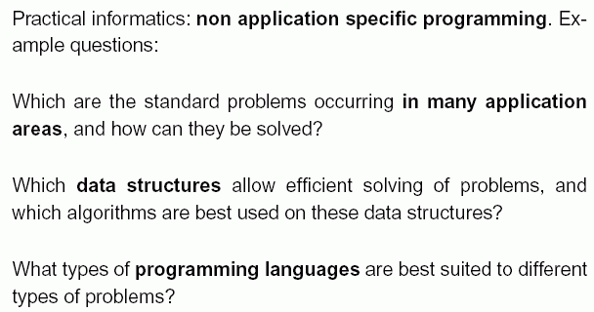

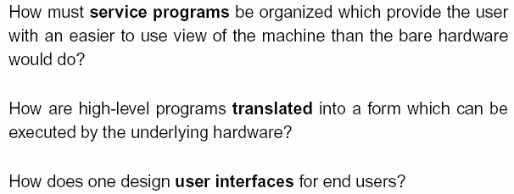

How does one organize the development process of large
software systems? ("Software engineering")

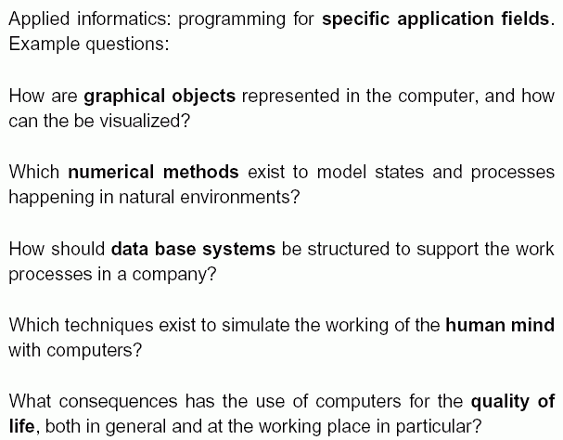

Informatics in the social context:

What ethical questions arise from the use of computers, and how can they be answered?
(data security, privacy questions, computer viruses, hackers, violence-promoting games, software piracy, ownership of software and ideas, use of information technology for warfare, for crime, for sexual exploitation, for terrorism...)

How does the use of computers influence our way of thinking (about the world, about humans, about the mind, about personal relationships of people...)?

How can computers and the WWW be used to improve education / autonomy of people / human rights / political participation... ?

2. Codes and number systems

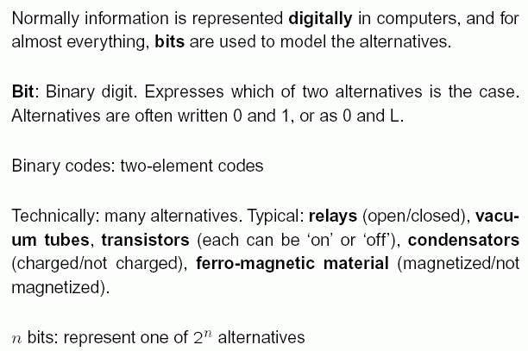

⇒ To represent information in a computer, we must encode all with the two symbols 0 and 1 !

What is a code ?

Code (1): A mapping f: A → B from a set A of elements to be stored or transferred to a set B used for storage or transfer.

Code (2): The set B from definition (1).

Example:
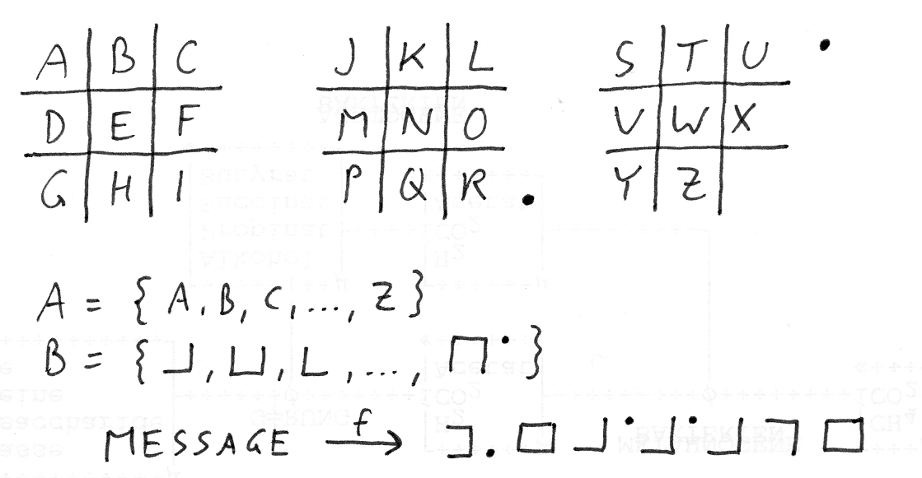
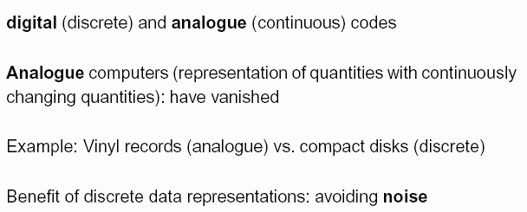

For digital computers, we need binary codes:
B is a set of combinations of 0 and 1.

Examples:

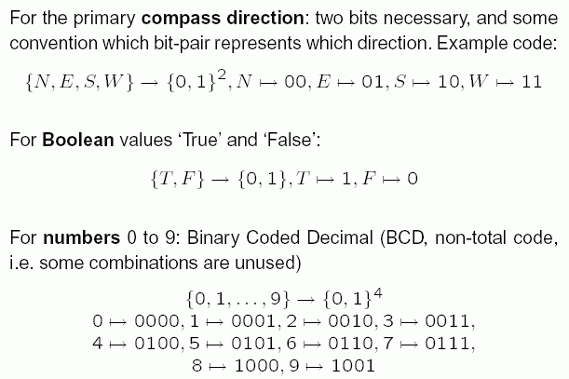

Multiples of bits

Bits seldom occur as singles. Certain multiples of bits are used as units for information (storage) capacity.

1 Byte: 8 bits (can represent 1 of 2⁸ = 256 alternatives).
Example: one of the integer numbers between
–128 and +127.
1 Halfbyte: 4 bits.

Typically, memory stores are built for multiples of bytes.

Prefixes: kilo, mega, giga, tera, peta, exa
- used in physics for the factors 10³, 10⁶, 10⁹, 10¹², 10¹⁵,
10¹⁸
- in computer science often used for the factors 2¹⁰, 2²⁰,
2³⁰, 2⁴⁰, 2⁵⁰, 2⁶⁰, which are slightly larger

abbreviation | meaning | factor
KB  MB  GB  TB  PB  EB | Kilobytes  Megabytes  Gigabytes  Terabytes  Petabytes  Exabytes | 2¹⁰ = 1024  2²⁰ = 1,048,576  2³⁰ = 1,073,741,824  2⁴⁰ = 1,099,511,627,776  2⁵⁰ = 1,125,899,906,842,624  2⁶⁰ = 1,152,921,504,606,846,976

Number systems

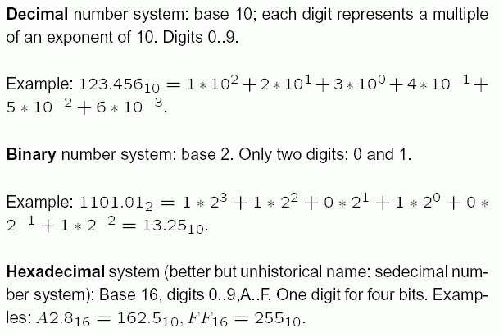
The additional digits in the hexadecimal system:
A = 10, B = 11, C = 12, D = 13, E = 14, F = 15.

Transformation from one number system to the other:

- Special case (easy): from binary to hexadecimal
Each halfbyte corresponds directly to a hexadecimal digit
Example: 0000 0010 1100 0110
→ 0 2 C 6

- from arbitrary system to decimal: Horner scheme
Input: z_{n–1} z_{n–2} ... z₀ to base b
start with h_{n–1} = z_{n–1}
calculate for k = n–1, n–2, ..., 0: h_{k–1} = h_{k} * b + z_{k–1}
Output: z = h₀

- from decimal to arbitrary: Inverse Horner scheme

start with h₀ = z ( = input)
calculate for k = 0, 1, 2, ...:
z_{k–1} = h_{k–1} mod b,
h_{k} = h_{k–1} div b
(mod: rest when dividing by b, div: integral part from dividing by b)

Output: z_{n–1} z_{n–2} ... z₀ to base b

